EXTENSION PROGRAM ASSESSMENT: A DUAL-FOCUS INTELLIGENT SYSTEM FOR FEEDBACK ANALYTICS
AND BENEFICIARY PERFORMANCE EVALUATION

A Capstone Project Presented to the Faculty, College of Computer Studies
Laguna State Polytechnic University
Los Baños Campus
Los Baños, Laguna

In Partial Fulfillment of the Requirements for the Degree
Bachelor of Science in Information Technology
Specialized in Web and Mobile Application Development

GIRONELLA, VAUGHN ROVIN
DIZON, ALISON RRYSALDI C.
AROCHA, CARL STEPHEN
ISIDRO, MARK ALAN B.

MARIBEL V. CARDONA

JUNE 2026

APPROVAL SHEET
The Capstone Project entitled “Extension Program Assessment: A Dual-Focus Intelligent System for Feedback Analytics and Beneficiary Performance Evaluation” prepared and submitted by Carl Stephen Arocha, Alison Rrysaldi C Dizon, Vaughn Rovin Gironella and Mark Alan B. Isidro in partial fulfillment of the requirements for the degree Bachelor of Science in Information Technology specialized in Web and Mobile Application development, is hereby recommended for approval and acceptance.

MARIBEL V. CARDONA
Adviser
Approved and Accepted by the Committee on Oral Examination with a grade of____.

GENE MARCK B. CATEDRILLA CAROLINA R. JOVAL
Member Member

JOCELYN O. PADALLAN JEFFERSON L. LERIOS
Member Member

Accepted in partial fulfillment of the requirements for the degree of Bachelor of Science in Information Technology, specialized in Web and Mobile Application Development.

LOYD S. ECHALAR
Associate Dean, College of Computer Studies

OFELIA B. MANINGAS, EdD. ____________
Chairperson, Research and Development Office Date Signed

RESEARCH CONTRIBUTION NO.

ACKNOWLEDGEMENT
The researchers would like to express their deepest gratitude to people who successfully contributed to the completion of this capstone project titled “Extension Program Assessment: A Dual-Focus Intelligent System for Feedback Analytics and Beneficiary Performance Evaluation”. The support and guidance of many individuals have been invaluable throughout this journey.
First and foremost, the researchers would like to extend heartfelt appreciation, especially to their research adviser, Mrs. Maribel V. Cardona, whose guidance, patience, and expertise have been invaluable throughout this journey. To the subject specialist, Mr. Gene Marck B. Catedrilla, whose critical insights and knowledge greatly enriched the development of the study, especially the system and the other panelists, Mrs. Carolina R. Joval Mrs. Jocelyn O. Padallan and Dr. Sherwin B. Sapin which refined the clarity and coherence of this work.
The researchers also express their gratitude to the Almighty God for granting their will, strength and perseverance in developing, implementing, conceptualizing and finalizing this Capstone Project and finally, they also give a huge thanks to their family for their support, understanding, giving motivations for them, and encouragement, which were the foundation for their success.

THE RESEARCHERS

DEDICATION
This work is wholeheartedly dedicated to Almighty God, whose strength, wisdom, and guidance have been the researchers constant support throughout this journey. To the Researchers’ beloved parents
Mr. Ireneo S. Cazeñas Jr & Mrs. Cerelina C. Arocha
Mr. Larry R. Dizon & Rainelda C. Dizon
Mr. Bryce Kevin B. Sumiran & Ms. Ma. Rhodora M. Gironella
Mr. Alvaro L. Isidro & Mrs. Simplicia B. Isidro
For their unconditional love, encouragement, and support have been the researchers' most powerful sources of strength. Their families' sacrifices, guidance, and belief in the researchers' goals pushed them to persevere and strive for perfection. The researchers are appreciative for the principles of hard effort, ethics, and resilience instilled in them, which helped them complete this study. This achievement would not have been possible without the continual presence and unwavering faith of their families. The researchers also express deep appreciation to their friends and classmates, whose encouragement, support, and camaraderie cheered them up during difficult moments and contributed considerably to their successful completion of this project.
VR.G
AR.C.D
CS.A
MA.B.I
ABSTRACT
The EduLink Extension Program Assessment System was developed to address the persistent problems faced by 4Ps or Pantawid Pamilyang Pilipino Program Beneficiaries, solo parents, seniors, LGU-assisted participants, and PESO-supported individuals in accessing quality educational support. Existing learning and evaluation processes rely on outdated, fragmented, and paper-based methods, which lead to inconsistent information delivery, delayed feedback, limited access to updated resources, and difficulty in tracking Beneficiary progress. To solve these issues, the system aims to provide a unified digital platform that modernizes information dissemination, streamlines evaluations through digital forms, centralizes data analytics, and functions as a Learning Management System (LMS). By doing so, it ensures that educational sessions become more organized, accessible, timely, and efficient for both Instructors and Beneficiaries. The researchers followed Agile Scrum. However, the quality of the developed system and the acceptance of the Beneficiaries have been analyzed in the proposed work using two different frameworks, namely ISO/IEC 25010 software quality guidelines, and Technology Acceptance Model. The quality of the proposed system has been analyzed based on the ISO 25010 guidelines, where the quality has been checked based on the following characteristics: Functional Suitability, Reliability, Performance Efficiency, Usability, Security, Compatibility, Maintainability, and Portability. The results have shown that all these criteria have received an average rating of Excellent, with a rating of Good for the reliability aspect, resulting in a mean score of 4.56, thus making the proposed system reliable, secure, and user-friendly. At the same time, the acceptance received from the users has also been analyzed using the Technology Acceptance Model, where the acceptance has been analyzed based on the following aspects: Perceived Usefulness, Perceived Ease of Use, and User Satisfaction. The result has shown that all these aspects have received a mean score in the range 3.56 to 3.59, thus making the aspect Highly Acceptable, thus being effective, useful, and satisfactory to the users.

Keywords: Pantawid Pamilyang Pilipino Program (4Ps), Learning Management System (LMS), Feedback System, Educational Support, Online Assessment, Agile Scrum, ISO 25010, Technology Acceptance Model (TAM)

TABLE OF CONTENTS

Preliminaries Page

Title Page i
Approval Sheet ii
Acknowledgement iii
Dedication iv
Abstract v
Table of Contents vi
List of Figures viii
List of Tables ix
Definition of Terms x

CHAPTER
I INTRODUCTION
Project Context 1
Project Objectives 2
Project Purpose 3
Scope and Limitation 6

II THEORETRICAL FRAMEWORK OF THE PROJECT
Review of Related Literature, Studies
and Systems 7
Synthesis and Relevance of the Study 21
Literature Matrix 22
Conceptual Framework 23

III METHODOLOGY
Project Design 24
System Architecture 24
Project Locale 26
Project Development 26 Agile Scrum 27
Product Backlog 28
Sprint Planning 30
Use Case Diagram 33
Flowchart 34
Materials 35
Software 35
Hardware 38
Project Testing and Evaluation 38
Unit Testing 38
Compatibility Testing 39
Integration Testing 40
System Testing 41
Evaluation Procedure 41
ISO 25010 41
Technology Acceptance Model 42
Population of the Study 43
Respondent of the Study 43
Data Collection Instrument 43
Likert Scale for TAM Survey 44
Statistical Treatment 44

IV RESULTS AND DISCUSSIONS
Results Based on the Objectives of the Study 46
System Assessment using ISO 25010 50
Result of Technology Acceptance Model 51

V SUMMARY, CONCLUSIONS, AND
RECOMMENDATIONS
Summary 58
Conclusions 59
Recommendations 60

REFERENCES
APPENDICES

Appendix A. Figures
Appendix B. Compatibility Result
Appendix C. Survey Questionnaire
Appendix D. Grammarly Result
Appendix E. Turnitin Result
Appendix F. Publishable Paper
Appendix G. Curriculum Vitae

LIST OF FIGURES
No. | Title | Page
1 | Conceptual Framework | 23
2 | System Architecture | 25
3 | Agile Scrum | 27
4 | Use Case Diagram | 34
5 | System Flowchart | 35
6 | Project Testing and Evaluation | 38
7 | Unit testing | 39
8 | Compatibility Testing | 40
9 | Integration Testing | 41
10 | Login Page of EduLink on Web and Mobile | 46
11 | Landing Page of EduLink for Beneficiary | 47
12 | Program page for Beneficiary | 47
13 | Landing Page of EduLink for Instructors | 47
14 | Program Page for Instructors | 48
15 | Administrator Dashboard Page | 48
16 | User Management Page | 49
17 | Program Management Page | 49
18 | Feedback Management Page | 50

LIST OF TABLES

No. | Title | Page
1 | Product Backlog for Beneficiary | 28
2 | Product Backlog for Instructor | 29
3 | Product Backlog for Administrator | 30
4 | Sprint Backlog for Administrator | 31
5 | Sprint Backlog for Beneficiary | 32
6 | Sprint Backlog for Instructor | 33
7 | 5-point Verbal Interpretation Scale for ISO survey | 42
8 | 4-point Verbal Interpretation Scale for TAM survey | 42
9 | Respondent of the Study | 43
10 | Likert Scale for TAM survey | 44
11 | Product Quality Assessment | 51
12 | Technology Acceptance Model (TAM) Evaluation Results | 51
13 | Evaluation Results of Survey Answers | 52
14 | Unit Testing for Beneficiary Module | 53
15 | Unit Testing for Instructor Module | 54
16 | Unit Testing for Administrator Module | 54
17 | Unit Testing for Notification Module | 55
18 | Compatibility Testing of the System | 56
19 | Integration Testing for System Module | 57

DEFINITION OF TERMS

Terms Definition

Pantawid Pamilyang Pilipino Program (4Ps) | A government program that gives financial help to poor families as long as they follow certain rules like attending school or health checkups.
Department of Social Welfare and Development (DSWD) | The Philippine government agency overseeing social protection programs, including 4Ps, responsible for implementation, monitoring, and development of social welfare services.
Beneficiaries | People who receive help or support from a program, such as 4Ps members, solo parents, seniors, and PESO clients.
Learning Management System | A digital platform that delivers learning materials, announcements, activities, and tracks Beneficiaries’ progress.
Local Government Unit | Municipal or city offices involved in implementing and monitoring community-based programs and providing access to educational or livelihood support.
Instructor | A person who teaches lessons, gives orientations, and guides Beneficiaries.
Beneficiary Performance Evaluation | An assessment process to measure Beneficiaries’ understanding, engagement, and participation in program activities using both online and scanned evaluation tools.
Public Employment Service Office (PESO) | A government office that provides employment and livelihood-related services; included as one of the target Beneficiary groups in the system.
Notification System | A feature of the platform that sends alerts to users regarding new learning materials, schedule updates, upcoming sessions, and other program-related information.
SDGs (Sustainable Development Goals) | Global development goals set by the United Nations. The project aligns with SDG 4 (Quality Education), SDG 8 (Decent Work and Economic Growth), SDG 9 (Industry, Innovation, and Infrastructure), and SDG 10 (Reduced Inequalities).

CHAPTER 1
INTRODUCTION
Project Context
The Pantawid Pamilyang Pilipino Program, also known as 4Ps, is an antipoverty program that serves as a social development and social welfare intervention. As a social welfare program, it is a conditional cash transfer (CCT) program that offers cash grants to extremely poor, targeted families. It empowers recipients through the economic support they are given while being molded into good citizens. In the process, the individuals who strictly comply with the rules continue to benefit. Conversely, it also generates another category that is either excluded or faces some anomalies. The program targets the human development of Beneficiaries (Seki, 2015). As of February 2024, approximately 4.4 million households were Beneficiaries of the program (Department of Social Welfare and Development, 2020).
Despite various efforts, several groups, including 4Ps Beneficiaries, single parents, seniors, LGU-supported individuals, and individuals assisted by PESO, continue to have difficulty obtaining the necessary educational assistance. This includes dependable instructional guidance, organized orientation programs, and high-quality learning materials. The existing information-dissemination strategies, which rely on antiquated infrastructure and conventional teaching methods by organizations and community facilitators, are ineffective. Inconsistent learning procedures, restricted access to current resources, and inadequate tracking of Beneficiary engagement are
all consequences of the lack of a single digital platform. Additionally, ongoing paper-based evaluations result in data processing delays, increase the likelihood of errors, and make it difficult to properly store and analyze feedback.
The EduLink Extension Program Assessment System is proposed to solve these problems through features such as digital forms, online feedback, and centralized analytics. Additionally, the system would serve as an LMS, allowing Instructors to upload learning materials, organize sessions, and track Beneficiaries' progress. This initiative helps improve the educational accessibility of 4Ps Beneficiaries, solo parents, seniors, LGU, and PESO participants.
Instead of using paper evaluation forms, which are more complex to store and slower to progress, the system allows Instructors to conduct digital evaluations. Beneficiaries can complete these assessments in the system after each face-to-face session. It ensures Instructors remain in their learning sessions face-to-face, and all review, feedback, and resource management become organized, timely, and accessible.
Project Objectives
The primary goal of this research is to develop an education monitoring and feedback system that enhances the delivery and evaluation of extension programs for local Beneficiaries. Specifically, the project aims to:
1. Create an extensive Learning Management System (LMS) to store course content, announcements, and offer a centralized repository for all course information.
2. Create an easy-to-use interface that is accessible on different devices (web and mobile), making it accessible regardless of technology that they have.
3. Integrate a built-in evaluation and feedback module that allows Instructors to conduct assessments for Beneficiaries directly within the system after every face-to-face session while enabling Instructors and Administrators to view and analyze the results for monitoring and performance evaluation
Project Purpose
The purpose of the project is to develop an Intelligent System for Feedback Analytics and Beneficiary Performance Evaluation as an integrated online portal for Beneficiaries (4Ps, solo parent, senior, PESO, LGU Beneficiaries). The system would enhance Beneficiaries' access and serve as a systematic channel for program orientations and announcements. With enhanced digital literacy, educational outreach, and inclusive learning, the project shall help achieve the SDGs 4, 8, 9, and 10.
Quality Education (SDG 4). The Instructors and program facilitators would provide orientation and upload learning materials for all Beneficiaries, including 4Ps Beneficiaries, solo parents, seniors, PESO participants, and individuals supported by the LGU. By providing access to educational content, discussions, and evaluation tools, the system would continue to help people learn and gather user feedback.
Decent Work Economic Growth (SDG 8). is to prepare people for work and economic independence by providing educational programs, livelihood-related materials, and informational resources. Through orientations, content uploads, and educational sessions, the instructors and facilitators help Beneficiaries to improve their financial understanding and employability.
Industry, Innovation, and Infrastructure (SDG 9). The development of this portal would revolutionize the delivery of education and research by adding learning management tools, performance evaluation, and resource sharing. The system would help improve the delivery of educational services and promote innovation in public learning operations.
Reduced Inequalities (SDG 10). All the Beneficiaries would have equal access to program updates and learning materials through the Intelligent System for Feedback Analytics and Beneficiary Performance Evaluation. Through the provision of structured orientation and online resources, the platform empowers the disadvantaged and keeps them updated on their registered programs.
Enhancing Efficiency. Instructors would effectively distribute learning materials and updates via the portal, ensuring that parents, senior citizens, and students can access the information they need anytime, anywhere. The educators would use this system to provide assistance, lectures, program updates, and learning materials to make their Beneficiaries well-informed about the programs. Additionally, the platform would notify Beneficiaries about upcoming sessions, updates, and new learning materials to watch or read.
Beneficiaries. The goal of this project is to enhance Beneficiaries' understanding by providing them with access to learning materials and program information, through evaluation, uploaded materials, face-to-face sessions, and an integrated evaluation form designed to measure whether they understood the lesson and whether the instructors performed efficiently. These evaluations would help Instructors improve future sessions, ensuring that Beneficiaries continue to receive high-quality teaching and support.
Instructors. The instructor would have the key role as facilitators of the system, holding orientation, discussions, and updates to Beneficiaries. The proposed system to improve tracking student progress and adjust instructional strategies as needed effectively is expected to streamline the evaluation process by digitizing paper-based forms and integrating online feedback mechanisms. This would improve data accuracy, reduce evaluation turnaround time, and facilitate timely monitoring and reporting. Moreover, the system would provide valuable insights for the Instructors, enabling them to effectively track student progress and adjust instructional strategies as needed.
Local Government Unit (LGU). The LGU would benefit from this system by having an organized and efficient way of delivering educational support to Beneficiaries
Future Researchers. To future researchers who are interested in creating online learning platforms for the community, this study would offer valuable information. Future studies can use this study as a basis to introduce additional features, improve the performance of the system, and identify additional applications of electronic learning in social welfare programs through documentation of the design and development of an Intelligent System for Feedback Analytics and Beneficiary Performance Evaluation. Future developments improving the inclusiveness and accessibility of government-sponsored education programs would be anchored on this study.
Scope and Limitation of the Study
Intelligent System for Feedback Analytics and Beneficiary Performance Evaluation aims to provide hybrid learning support to 4Ps Beneficiaries and solo parents in Los Baños, Bay, PESO Bay, and Bayanes. The system includes required features like Administrator user account Administration, classroom configuration and maintenance, attendance tracking, and assignment submission with grading. Teachers or 4Ps facilitators can upload learning materials like documents and videos. Online and offline learning can be supported, and each learning session is followed by an assessment. The results of these assessments would be processed for data visualization and analysis to gain greater insights into participation and learning outcomes.
Limitations existing on the full use of the online modules through internet access are essential for this. Although the system allows users to view and reply, they cannot post updates or upload materials. Teachers would not be allowed to manage user accounts, as that privilege would only belong to the Administrators. Ethical considerations were prioritized by limiting data visibility to Administrators only. By ensuring total anonymity, the design mitigates privacy concerns and encourages objective evaluation, as respondents are shielded from potential biases associated with disclosure. The data visualization tools only allow for visualization and analysis of data that the system has collected.
CHAPTER 2
THEORETICAL FRAMEWORK OF THE PROJECT
Review of Related Literature, Studies, and Systems
This chapter provides an extensive overview of relevant research and literature from both domestic and international sources, as published in journals, conference papers, and articles. The researchers would use it as a guide as they carry out the study. To clarify and understand the study's significance, it also links to and analyzes several previous studies.
Evolution of Online Learning
Online learning, which focuses on Beneficiaries' needs and offers flexibility, provides students with opportunities to pursue education outside conventional classroom environments (Howard & Maton, 2011; Wang, Bruce, & Hughes, 2011). Initially, correspondence courses depended on the postal system. However, as technology advanced, thanks to inventions like radio, television, and the internet, online learning became more accessible and interactive (Li, 2018). These findings highlight the significance of integrating technology into education, as they help Beneficiaries adapt to various learning options.
Additionally, a review of 86 studies involving more than 15,000 students shows that distance education (DE) often outperforms face-to-face (F2F) instruction in academic outcomes (Shachar & Neumann, 2020). This finding challenges the common belief that F2F is the best teaching method and
raises an important question: “Is F2F right for all students?” (Shachar & Neumann, 2020). These findings might change how we see education. However, this study highlights the issue of bias in research, ensuring that what we find is transparent and trustworthy. As distance education shows its potential, it should be carefully considered to prevent exaggeration.
Collaborative Learning and Peer Interaction
The U21G eLearning model emphasizes collaboration, integrating teamwork into the curriculum to enhance peer learning. In addition to facilitating knowledge exchange, Teo & Williams (2005) highlight that team projects give students the chance to practice collaborative problem-solving, an essential ability in today's business. The course design ensures that students can interact with one another in ways that support learning together. This collaboration gives students insight into the idea that the answer they are looking for won't emerge in individual work, but through sharing ideas with their peers.
Self-Paced Learning and Time Management
This study highlights the several advantages and challenges of online learning. The benefit of working at your own pace is that it allows the student to focus their time on more difficult activities (Gilbert, 2015). However, this flexibility also presented challenges, including difficulties with time management, unreliable internet access, and some students lacking home internet and needing to use libraries or computer cafés. Despite all these challenges, the ability to use online resources and work at your own pace was seen as a valuable aspect of online learning.
Effectiveness and Limitations of Online Learning
Kayalar (2021) investigates how two university students viewed the effectiveness of synchronous and asynchronous learning models. The results show that most students do not favor distance education as a learning modality. Some students reported that using computers and online tools helped them learn faster, particularly in geography courses. However, others believed that more interactive activities, such as on-site learning and project-based learning, were necessary for academic success. The use of technology is essential not only in geography courses but in all subjects. However, its implementation can only be successful if it is carried out correctly by teachers who embrace technology within the educational system.
A study from NoSignificantDifference.org found that 92% of studies show that online education is more successful than traditional education. 3% of studies favor face-to-face learning, while 4% show mixed findings. It shows that problems such as selection bias and inconsistent research methods limit the reliability of the results (Nguyen, 2015). There is insufficient data to draw a line between the two modalities (Lack, 2013). Most studies yield mixed results, and researchers should be cautious when interpreting their findings or generalizing them to other settings.
Additionally, using 1000 student data as the sample size provides a high level of statistical power, making it easier to detect minor effects on participation in discussion forums (Zulfikar et al., 2019). The findings highlight that smaller studies with small samples might fail to identify these impacts. However, this data shows that participation also varies across classes, with some classes having fewer posts but higher student engagement, while others show the opposite. These results suggest that participation can vary significantly, even within similar contexts.
Role of Feedback in Online Learning
The study by Varkey et al. (2022) highlights that online learning settings should provide clear, concise, and valuable feedback. Poor feedback delivery can lead to confusion, demotivation, and hinder student growth. This study argues that vague feedback, such as "improve grammar" or "read more," fails to offer helpful suggestions for development. Feedback should focus on being specific on steps students can take to improve their knowledge, and on making it more formative than punitive. Good feedback gives students the confidence to take their first steps toward growth.
Digital Divide and Accessibility Issues
The digital divide was caused by the lack of internet access, which significantly affects university education (García Zare et al., 2023). Fair learning opportunities are hindered by this gap, especially in areas with limited resources. In the public sector, there should be policies and educational initiatives that prioritize areas with restricted access to address these problems and ensure that students in these areas can participate in their academic settings. While technology offers many benefits, it also has drawbacks. Those in areas with limited resources limit their communication and are unable to use specialized software, which is essential for developing a wide range of skills. Therefore, improving one's experience and advancing digital equity requires upgrading their infrastructure devices and granting them access to suitable devices.
Students with learning disabilities have shown great potential to improve their academic results through educational technology, especially mobile applications. The mobile app was effective in screening for different learning disabilities, such as dyslexia, dyscalculia, ADHD, and auditory processing disorder (APD), (Dijana Capeska Bogatinoska et al., 2024). The app shows promising results in students' academic performance after use and excellent accuracy in identifying these disabilities. Therefore, educational technology can be used for students who find it challenging to learn in standard settings.
Research and Policy Implications of Synchronous Hybrid Learning
Synchronous hybrid learning shows potential for student accessibility and participation; however, issues with pedagogical design and technology infrastructure persist. Raes et al. (2019) claimed that current research provides little data on long-term outcomes, focusing instead on students' experience and its implementation. Future research should use long-term studies, real-time analysis, and larger sample sizes to fill gaps by evaluating interactions and participation. A smaller sample size might fail to identify these impacts.
Institutions must create rules to address these issues to implement synchronous hybrid learning (Raes et al., 2019). Effective implementation will be ensured by a well-designed framework that enables smooth communication between the student and teacher. It will take significant study, development, and policy change to create the best hybrid learning environment.
Learning Management System (LMS)
For almost 30 years, learning management systems have been a component of the e-learning ecosystem. One of the few e-learning-related developments that has persisted to this day is the learning management system (LMS). Learning management systems served as the focal point for all online learning activities during the first 10 years of e-learning adoption. A learning management system (LMS) is a software application for the administration, documentation, tracking, reporting, automation, and delivery of educational courses, training programs, materials, or learning and development programs. It is designed to replicate the real teaching and learning process, providing students with access to learning materials 24/7 at their own convenience. According to Ryann K. Ellis in the book A Field Guide to Learning Management Systems (2009), an LMS is a software application that automates the administration, tracking, and reporting of training events.
As Araújo Júnior and Marquesi (2009) said, a Learning Management System, disseminated extensively as LMS, and, thus, the use of this abbreviation in this study can be justified, from the user's perspective, as an online environment that attempts to simulate the face-to-face learning spaces by means of Information Technology. In an LMS, communication is enabled by devices that facilitate it. LMS provided teachers and students with an online classroom that reinforces learning processes.
Learning Management Systems in Education
One major problem in traditional learning is the lack of preparation among teachers and students for the learning process. Furthermore, while the teacher's explanations and brief notes have limitations in terms of knowledge transfer, the supplied educational material cannot be repeated. To address these problems in today's technology-driven societies, academic institutions, particularly those at the tertiary level, are incorporating Information and Communication Technologies (ICTs), and faculty are experimenting with them to augment their traditional teaching methods. It has been demonstrated that online learning management systems (LMS) can assist in such endeavors.
One study by Tus et al. (2021) found that LMS improves the range of the learning environment for students. This provides an easy and very accessible classroom for students and teachers. In another study, Dias and Dinis (2014) and You (2016) found that students who kept track of their online assignments by continually logging in to the online course and reading course materials frequently performed well. The results reveal the benefits of self-attained knowledge and the ability to front-load specifications to support student attainment. The use of web-based instructional materials has given students the convenience of learning from anywhere, anytime, improving accessibility, and fostering self-directed learning.
Types of Learning Management Systems
In line with the goals and learning objectives, learning management systems (LMS) give users the flexibility to create and manage learning (Hunt, 2010). LMSs come in two types: (1) Proprietary LMSs like Apex Learning, Blackboard, Intralearn, SAP Enterprise Learning, Saba Software, and others; and (2) Open-source LMSs like A Tutor, Claroline, Dokeos, ILIAS, Moodle, Sakai, and others (Barreto et al., 2020). A proprietary LMS is simple to develop and use, but extremely costly. An open-source LMS is free, but maintenance and updates will be paid for.
Moodle, as one example of an Open-source LMS, is a safe, multilingual, and flexible setting for teachers and students. In the study by Zabolotniaia and Cheng (2020), it is stated that implementing Moodle in higher education expands university coverage by facilitating distance learning, increasing student participation, and maximizing institutional resources.
With more LMS providers, selecting the appropriate platform depends on institutional needs. One study by Poulova et al. (2015) compared Blackboard and EKP (a Proprietary LMS) with Moodle and Claroline (open-source LMSs). It shows that Blackboard and EKP share 80% of the same tools, and Moodle and Claroline provide low-cost options with slight variation in core functionalities. The biggest differentiator is cost: Moodle and Claroline are open source and free, while Blackboard has licensing costs.
The most crucial factor in student satisfaction is whether the LMS's feature set is suitable for their needs and facilitates their use. Each platform has its own strengths and weaknesses; hence, LMS platforms should be chosen based on users' needs.
Poverty Reduction and the 4Ps Program in the Philippines
Pantawid Pamilyang Pilipino Program (4Ps) is a conditional cash transfer (CCT) program that provides financial support to low-income households with children aged 0-14. The program meets the short-term and long-term needs of its Beneficiaries by requiring recipients to maintain regular health examinations and school attendance (Fernandez & Olfindo, 2011). This method helps reduce financial issues while preparing the future generation with health and knowledge to end the cycle of poverty.
Impact of the 4Ps Program on Poverty Reduction in the Philippines The poverty rate in the Philippines decreased sharply between 2008 and 2015 due to economic expansion and government interventions, especially the Pantawid Pamilyang Pilipino Program (4Ps). There's a 0.71% yearly decline in the poor population (Simeon, 2021). Almost a million people benefited from this program between 2009 and 2011, which emphasizes the significance of government intervention in reducing poverty. Furthermore, the critical part of the 4Ps was always education, which supports the idea that investing in education yields long-term socioeconomic gains. In the study by Flores et al. (2019), as financial aid increases, the probability of the student dropping out decreases. A 2011 DSWD survey found that increased educational options and financial assistance improved Beneficiaries' academic achievement. The results of this study show that the 4Ps are among the key factors in reducing educational gaps, which are vital to the country's growth and productivity.
Health and Nutrition Benefits of 4Ps
A study by Organo (2023) shows that the 4Ps improve beneficiaries' health and nutrition by reducing the incidence and severity of illness. The improved overall health of people demonstrates that financial assistance, when paired with health-related issues, can reduce child mortality rates and improve prenatal health in low-income households. The program promotes routine health examinations and maternal care. This advantage highlights how well the program enhances people's well-being, which may lead to the end of the cycle of poverty.
Challenges in 4Ps Implementation
Implementing the Pantawid Pamilyang Pilipino Program (4Ps) comes with challenges such as supply shortages, administrative complexity, and resource constraints (Babasa, 2019). Transferring it to LGUs results in a lack of institutional capacity to fully implement and monitor 4Ps effectively. This is also accompanied by poor coordination and service gaps, with a lack of monitoring resulting in reduced transparency and accountability. Therefore, to properly utilize the 4Ps program for its intended purpose, it is necessary to improve its whole process.
Institutional Monitoring and Feedback
Uncontrollable emergency scenarios can shift teaching methods and impact the sustainability of higher education institutions. Such unforeseen circumstances necessitate quick involvement by institutional monitoring and input, which is, in many respects, a shared obligation. However, because the process requires managerial-level work from the very beginning, it addresses the relevant issues. In a study conducted by Ayeni (2012), 60 principals and 540 teachers were randomly selected to assess the efficiency of principal supervision of teachers' instructional tasks in secondary schools in Ondo State, Nigeria. Ayeni (2012) presented numerous monitoring approaches based on Ogunsaju (1983) and Peretomode (1995).
The tactics include clinical supervision, research, micro-teaching, and seminar/workshop approaches. Goldhammer's (1969) clinical supervision technique involves five stages: (i) pre-observation conference between supervisor and teacher; (ii) classroom observation; (iii) supervisor's analysis notes; (iv) post-observation conference between supervisor and teacher; and (v) supervisor's post-observation analysis. The research technique is more democratic since the supervisor encourages Instructors to conduct action research to solve their identified teaching-learning problems. Micro-teaching is a reflective strategy in which teachers, supervisors, and students use video recordings to develop new teaching skills. The seminar/workshop technique involves repeating courses with the same group and providing feedback, allowing a small group to assess common teaching-learning challenges through hands-on experiences critically.
In another study, treating students as crucial stakeholders in the institutional monitoring system, AlMahrooqi et al. (2015) worked with 62 English language foundation students at Oman's Sultan Qaboos University (SQU), reviewing various parts of the university's English foundation curriculum. The study suggests producing EFL textbooks that are culturally grounded and involve students in the curriculum design process. McDonough and Chaikitmongkol's (2007) study found that materials development, teacher-student preparation, and timely course evaluation are crucial for the success of a task-based EFL course at Chiang Mai University in Thailand.

Educational Opportunities for Older Adults
Armed with knowledge of the demographics of the senior population and the fallacies associated with aging, a clearer understanding of the value of education for our elderly has emerged. Acceptance of the principles and concepts of lifelong learning is associated with a greater emphasis on sustaining educational goals throughout one's life. There are three types of education for older people: 1) programs with particular privileges for seniors; 2) existing programs adapted or modified to meet the special needs of seniors; and 3) programs established and explicitly offered for seniors (Lumsden, 1985).
Education Opportunity & Teaching for Solo Parents
Recent studies have highlighted the challenging educational realities that single parents and their children endure. Dai et al. (2025) found that structured home-school collaborative interventions assist students from single-parent households by dramatically improving their resilience, emotional control, and goal concentration. This emphasizes the critical role that educators play in collaborating with single parents to support children's socioemotional learning. To support this viewpoint, Maro et al. (2024) found that solo working parents experience moderate to high difficulties balancing career responsibilities with their children's educational needs, particularly in attending school activities and providing consistent academic support. These limitations are often due to time, budgetary, and institutional capacity constraints. Beneficiaries also describe specific challenges associated with single parenthood. Dote and Garcia (2025) discovered that adolescents raised by single parents usually struggle with emotional burdens, financial stress, and a desire for parental presence. Still, they also demonstrate resilience and empathy characteristics that impact their academic behaviors and school participation.
Research in the Philippines contributes to a better understanding of the sociocultural and legal landscapes that influence lone parents' educational potential. According to Lucero-Dueñas (2025), solitary parents have barriers to accessing social and educational help due to societal stigma and limitations in policy implementation. Similar themes arise in Arcilla et al. (2025), who discovered that single parents caring for very young infants face considerable emotional, physical, and resource-based problems that limit their ability to participate in early childhood education activities fully. Shitindia (2025) observed that single parents living in street-connected contexts face extreme barriers to their children's education, including safety concerns, social discrimination, and a lack of institutional support, emphasizing the compounded disadvantage experienced by marginalized single-parent families. Meanwhile, Lopez et al. (2024) studied single mothers pursuing higher education, revealing challenges such as financial strain, time management, and limited institutional support, while also demonstrating these students' perseverance and motivation to continue their studies despite adversity. Collectively, these studies show that both solo parents and their children face interconnected emotional, economic, and structural challenges, emphasizing the need for more flexible school policies, increased teacher-parent collaboration, and improved institutional support to promote educational opportunity for single-parent families.

Quality vs. Access
Research indicates that access alone does not guarantee meaningful learning, despite global advances in expanding free education. About 70% of 10-year-olds in low- and middle-income countries are unable to read and understand simple text, according to the UNICEF–World Bank *State of Global Learning Poverty* (2022). This problem predates COVID-19 but has worsened due to school closures and economic disruption. The issue is worse in the Philippines, where 91% of 10-year-olds are unable to read passages that are appropriate for their age. This is primarily because of inadequate classroom instruction, poor teaching quality, and teacher absenteeism.
According to PIDS, systemic problems like persistent underfunding result in overcrowding in classrooms, a lack of learning resources, and insufficient support systems. According to Wong (2024), free-education systems frequently fail because they disregard equitable resource allocation, teacher preparation, and infrastructure. In general, the literature emphasizes that eliminating fees is only the beginning; real educational equity necessitates ongoing funding for educators, resources, and structural changes that put learning ahead of attendance.
Synthesis and Relevance of the Study
The study highlights the flexibility and effectiveness in providing educational opportunities beyond the traditional teaching (Howard & Maton, 2011; Wang et al., 2011). Online education can sometimes surpass on-site learning in academic outcomes (Shachar & Neumann, 2020). However, the issue with time management, accessibility, and digital fairness still remains among the disadvantaged groups (Gilbert, 2015; García Zare et al., 2023). The idea of feedback systems and collaborative learning was integrated to increase student engagement (Teo & Williams, 2005; Varkey et al., 2022).
LMS or Learning Management Systems are essential in online education since they provide a platform for information delivery and interaction (Ellis, 2009). Some of the LMS cater to different needs, like Moodle, which promotes accessibility and participation (Zabolotniaia & Cheng, 2020).
Reducing poverty, boosting education, and improving the welfare of low-income families are all made possible by the Pantawid Pamilyang Pilipino Program (4Ps) (Fernandez & Olfindo, 2011; Simeon, 2021). Research indicates that financial aid boosts socioeconomic growth and school retention rates, but the program's full potential is hampered by resource constraints and management problems (Flores et al., 2019; Babasa, 2019). The Intelligent System for Feedback Analytics and Beneficiary Performance Evaluation, which offers 4Ps Beneficiaries easily accessible online resources and learning opportunities through LMS features and interactive platforms, was developed as a result of these findings. The system encourages skill development, inclusive education, poverty alleviation, and social empowerment.

LITERATURE MATRIX
Author | Year | Title | Finding
Shachar & Neumann | 2003 | Differences between Traditional and Distance Education Academic Performances: A Meta-Analytic Approach | The study found out that the distance learning frequently outperforms the traditional face to face learning due to its flexibility of the student to learn at their own pace which leads to better outcomes in some cases.
Gilbert | 2015 | Online Learning: Revealing the benefits and challenges | The research identifies that self paced learning provides the student with the benefit of concentrating on challenging tasks and learning material at their own pace.
Kayalar | 2021 | Perspectives of university students on the efficiency of synchronous and asynchronous learning | University students prefer on-site learning but value online classes for flexibility and access to resources.
Zulfikar et al. | 2019 | The Effectiveness of Online Learning with Facilitation Method | This study highlights student participation and engagement in online learning are influence by the course design.
Varkey et al. | 2022 | Asynchronous learning: A general review of best practices for the 21st century | This study shows that giving detailed and constructive criticism in online learning can significantly enhances student understanding, participation, and academic achievement.
Shitindia, S. J. | 2025 | Single Parenthood and Streetism: The Hidden Struggles of Street Children and Single Parents | Street-connected solo parents face extreme educational barriers: safety issues, heavy stigma, lack of institutional support, and heightened social vulnerability.
Wong, E. | 2024 | Rethinking Free Education: Why Cost Removal Alone Cannot Ensure Learning Equity. | Free education programs fail when they neglect infrastructure, teacher training, and equitable resource allocation.
Lucero-Dueñas, G. F. | 2025 | Societal Perceptions, Legal Frameworks, and Lived Experiences of Solo Parents in the Philippines | Solo parents struggle with social stigma and gaps in policy implementation, limiting their access to educational and social support programs.
Poulova et al. | 2015 | Which one, or another? Comparative analysis of selected LMS | Open-source learning management system (LMS) software products provide schools cheaper options without lacking in features important for improving beneficiaries' study process.
Ayeni | 2012 | Assessment of Principals’ Supervision of Teachers’ Instructional Tasks in Secondary Schools in Ondo State, Nigeria | Effective supervision enhances instructional quality by systematically applying monitoring approaches that improve teaching effectiveness.

Conceptual Framework
The researchers used the Conceptual Framework to illustrate the conceptual framework for designing and implementing the Intelligent System for Feedback Analytics and Beneficiary Performance Evaluation, comprising three main components: Input, Process, and Output. In the Input phase, Beneficiaries, Instructors, and Administrators access the platform via computers or mobile devices; Beneficiaries retrieve lessons and submit evaluations, Instructors manage classes and upload content, and Administrators oversee the system and handle analytics. The Process phase covers user interaction with the Content Management System, enabling material access and evaluation management. The Output phase provides an integrated database where user responses, feedback, and evaluation results are stored, analyzed, and transformed into actionable reports to support efficient information delivery and performance evaluation.
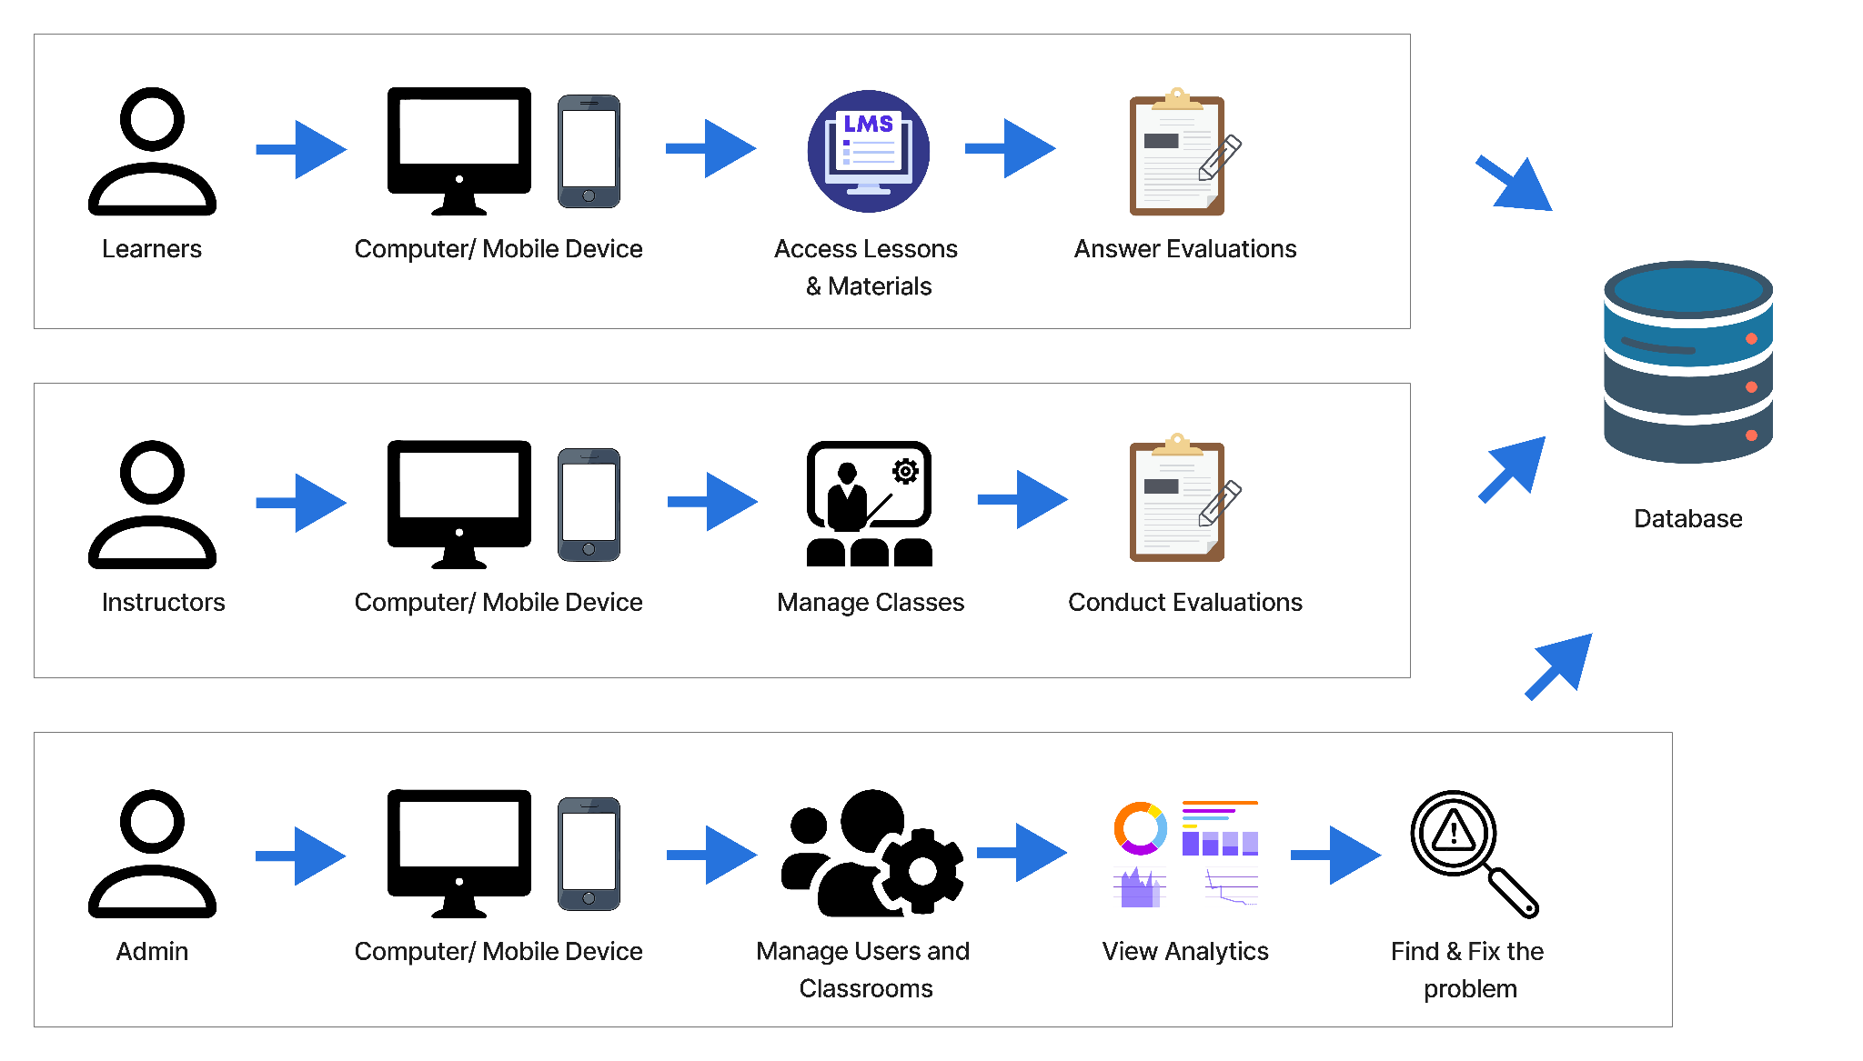
Figure 1. Conceptual Framework

CHAPTER 3
METHODOLOGY
This chapter discussed the methodology and the techniques used in the research. Researchers in this field use a systematic approach to achieve their goals. To direct their work on the project, researchers use different strategies. It illustrated the database, hardware, software, and data gathering.
Project Design
The architecture of the Intelligent System for Feedback Analytics and Beneficiary Performance Evaluation is purposefully designed to support multifaceted educational outreach targeting 4Ps Beneficiaries, solo parents, senior citizens, PESO, and LGU across designated locales. The system is built on a web-based platform that integrates three core components—the User Interface, the Administrator Interface, and a centralized Database—to support learning management, feedback analytics, and synchronous communication.
The User Interface serves as the primary access point for both Beneficiaries and Instructors. Beneficiaries, including students, parents, and seniors, use this interface to access educational materials such as documents and multimedia resources, participate in interactive forums, receive real-time notifications, complete digital assessments, and submit attendance forms. Instructors share similar access but are provided with additional capabilities, including uploading learning materials, creating and grading assignments, managing evaluation forms, monitoring attendance, and organizing session schedules. The interface is designed using responsive technologies to ensure
accessibility across various devices, helping address differences in digital literacy and device availability.
The Administrator Interface, together with the Centralized Database, ensures the system’s operational stability and data-driven functionality. Administrators manage user accounts, programs, and system activities while monitoring performance through audit trails and usage reports. The centralized database securely stores user profiles, learning content, schedules, attendance records, discussion threads, and generated reports, enabling real-time data retrieval, updates, and analysis. Strong data security and integrity measures are implemented to protect confidentiality while supporting evidence-based monitoring, feedback analytics, and program evaluation.
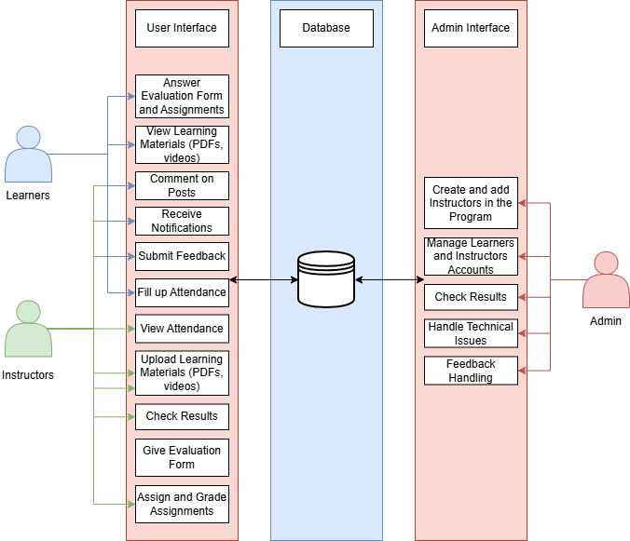
Figure 2. System Architecture

Project Locale
The Dual-Focus Intelligent System for Feedback Analytics and Beneficiary Performance Evaluation will be implemented within Los Baños, Laguna and Bay, Laguna.
Project Development
The development would begin with the Planning and Requirements Gathering phase, where the team would define the system’s core features, user roles, functional modules, and overall architecture. This stage involves consultations with faculty, technical experts, and community representatives to identify both educational and extension-related needs. Next, in the Design phase, the system’s database schema and visual UI mockups would be created to guide coding and interface development.
The Development phase would involve building the platform using modern web technologies, including Next.js with TypeScript for both frontend and backend logic, Tailwind CSS for responsive design, PostgreSQL as the central database, and real-time communication via Socket.IO. Once core functionalities are in place, the Testing phase would commence, including unit testing, integration testing, API testing, and User Acceptance Testing (UAT). After thorough testing, the system would enter the Deployment phase, using Docker to containerize the application for efficient self-hosting, scalability, and multi-device access.
Finally, during the Evaluation phase, the system would undergo usability and performance testing. Feedback from pilot users, including faculty and 4Ps participants, would be gathered to identify issues and guide future improvements, ensuring alignment with educational and community objectives.
Agile Scrum
Software development methods like Agile Scrum prioritize flexibility, collaboration, and gradual progress.
The Agile Scrum methodology is suitable for our system, which has role-based access, interactive features, and real-time changes. Beneficiaries can read documents, leave comments, log in, and receive notifications, while the Administrator focuses on access control, oversees content, and manages interactions. This methodology enables gradual development and focuses on features such as access control, authentication, and material management. This adaptability allows adjustments to user input, ensuring the system meets Beneficiary requirements. Agile methodology reduces errors and enhances system quality, making it productive and flexible for future improvement on an accessible platform.
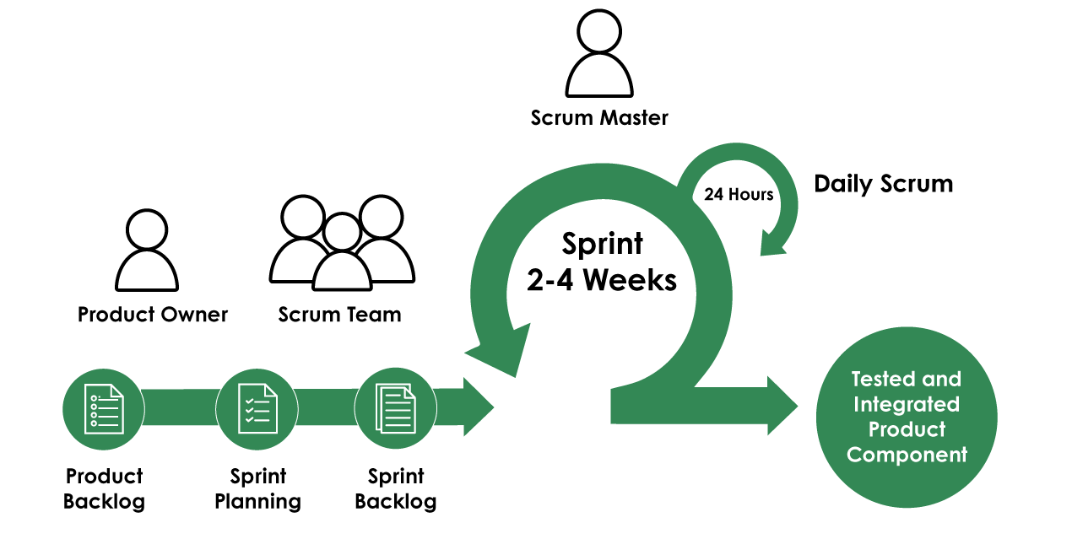
Figure 3. Agile Scrum
Product Backlog
A prioritized list of the system's features and requirements may be found in the product backlog. Both Administrator and User features are included, guaranteeing that all crucial elements are created iteratively. This backlog serves as a structured guide for the development team, enabling effective sprint planning, progress tracking, and alignment with the overall objectives of the system.
Table 1 shows the prioritized Beneficiary-side product backlog, with brief user stories and 1–5-hour weekly estimates. Core features—content access, announcements and schedules, evaluations, and commenting—are implemented first to meet Beneficiaries’ basic needs using the Intelligent System for Feedback Analytics and Beneficiary Performance Evaluation.
Table 1. Product Backlog for Beneficiary
PRIORITY | ITEMS | ESTIMATED HOURS / DAY
1 | As a Beneficiary, I want to access course materials anytime. | 2 Hours
2 | As a Beneficiary, I want to view announcements and session schedules. | 2 Hours
3 | As a Beneficiary, I want to answer evaluations after each session. | 2 Hours
4 | As a Beneficiary, I want to comment and reply to interactions. | 1 Hours

Table 2 shows all the functionalities and features explicitly required for the instructor role in the Intelligent System for Feedback Analytics and Beneficiary Performance Evaluation. This highlighted the key teaching activities and interactions that are necessary for successful remote teaching. Instructors need to facilitate learning, provide resources in a timely fashion, and maintain Beneficiary engagement. The activities outlined in this backlog map to these tasks, e.g., moderating discussion, posting learning content, and planning face-to-face sessions. Each item is ranked according to its relevance to learning delivery and its impact on the Beneficiary experience, so that essential items are developed and implemented effectively during the project development phase. This prioritization ensures that the most critical Instructor functionalities are addressed first, supporting effective instruction and consistent learning outcomes throughout the system.
Table 2. Product Backlog for Instructor
PRIORITY | ITEMS | ESTIMATED HOURS / DAY
1 | As an Instructor, I want to upload learning materials for Beneficiaries. | 3 Hours
2 | As an Instructor, I want to manage classroom sessions. | 3 Hours
3 | As an Instructor, I want to conduct evaluations within the system. | 1 Hour
4 | As an Instructor, I want to review evaluation results to assess Beneficiary understanding. | 2 Hours

Table 3 presents the Administrator-side product backlog with the highest-priority tasks and features to be addressed for the Intelligent System for Feedback Analytics and Beneficiary Performance Evaluation Administrators. These features are required to help Administrators successfully manage users, programs, evaluation results, and feedback. Each user story reflects the responsibility of the Administrator role and has an estimated development time of 1–5 hours per week. This backlog serves as a guide for system development, ensuring that Administrator functionalities align with the system goals. Additionally, it helps the development team prioritize implementation and track progress while maintaining consistency with the overall system requirements and stakeholder expectations.
Table 3. Product Backlog for Administrator
PRIORITY | ITEMS | ESTIMATED HOURS / DAY
1 | As an Administrator, I want to manage user accounts so that I can control access. | 4 Hours
2 | As an Administrator, I want to create, edit, and delete programs for course handling. | 3 Hours
3 | As an Administrator, I want to review evaluation results submitted by the Beneficiaries. | 2 Hours
4 | As an Administrator, I want to manage feedback submitted by users. | 2 Hours

SPRINT PLANNING
Sprint planning aligns the project’s priorities with specific tasks to be completed within each sprint. This involves breaking down the product backlog into actionable sprint backlogs for each user role: Administrator, Beneficiary, and Instructor. The objective is to ensure that the Intelligent System for Feedback Analytics and Beneficiary Performance Evaluation effectively deliver targeted functionalities that support both hybrid learning and evaluation processes.
Table 4 lists the priority features and tasks required for the management and operational control of the Intelligent System for Feedback Analytics and Beneficiary Performance Evaluation. The activities focus on key administrative features, including user management, program management, system feedback, and access control to ensure secure and efficient system use. Priority activities such as user and database management are covered in early sprints to establish a foundation for the system and reduce potential technical risks. The structured sprint assignments ensure that core backend functionality is developed first, facilitating the deployment of user-facing features while allowing administrators to effectively monitor system performance and maintain data integrity.
Table 4. Sprint Backlog for Administrator
PRIORITY | ITEMS | TASK | ESTIMATED HOURS / DAY
1 | As an Administrator, I want to manage user accounts. | -Design UI for user management  -Set roles /permissions | 3 Hours  2 Hour
2 | As an Administrator, I want to manage classrooms. | - Create classroom UI  -Implement create/edit/delete | 3 Hours  2 Hours
3 | As an Administrator, I want to manage system feedback. | -Create Feedback UI and backend | 4 Hours

Table 5 shows the planned development to enhance the experience of 4Ps Beneficiaries and solo parents through the Intelligent System for Feedback Analytics and Beneficiary Performance Evaluation. Ensuring accessibility, user involvement, and device usability are the main goals of this program. By bridging the communication gap between beneficiaries and administrators, the system fosters a more responsive support environment tailored to marginalized groups. Features such as secure login, learning resources, interactive discussions, and notifications would cater to these Beneficiaries. This inclusive digital framework ensures that essential services remain reachable while empowering users to engage actively with the platform. Every task is ranked by its significance and the approximate number of hours required to complete it during the sprint. This structured approach helps the development team prioritize critical functionalities while maintaining efficient time management. It also ensures that system features are delivered progressively and aligned with the needs of the target users.
Table 5. Sprint Backlog for Beneficiary
PRIORITY | ITEMS | TASK | ESTIMATED HOURS / DAY
1 | As a Beneficiary, I want to log in so that I can access my account. | -Login UI Design  -Authentication system | 3 Hours  3 Hour
2 | As a Beneficiary, I want to view documents and videos. | -Media viewer  -Access roles | 2 Hours  2 Hour
3 | As a Beneficiary, I want to comment and reply to interactions. | -Create comment system  -Connecting to database | 3 Hours  2 Hours
4 | As a Beneficiary, I want to receive notifications for new materials. | -Create notification system  -Set trigger in actions | 2 Hours  2 Hours

Table 6 lists the activities from the product backlog to be completed in this sprint. The selection of activities is guided by their importance and feasibility in delivering core features that enhance the platform's instructional value. This sprint aims to provide tools that enable Instructors to upload learning materials, manage classroom activities, such as conducting evaluations or assigning assignments, and view students' performance in their activities and their assessment in their learning sessions. With these features, educators are assured they have the tools at hand to manage students, programs, and activities, and to assess Beneficiaries' performance and progress.
Table 6. Sprint Backlog for Instructor
PRIORITY | ITEMS | TASK | ESTIMATED HOURS/ DAY
1 | As an Instructor, I want to upload learning materials. | - File upload module  - Storage setup | 3 Hours  3 Hours
2 | As an Instructor, I want to manage classroom activities. | - Activity creation UI  - Manage submissions | 3 Hours  2 Hours
3 | As an Instructor, I want to check Beneficiary performance. | - UI for viewing scores | 2 hours

Use Case Diagram
Figure 4 illustrates three core actor groups: Beneficiaries (Students, Parents, and Seniors), Instructors (Teachers, 4Ps, PESO, and LGU officials), and Administrators (system managers) who oversee system operations, user accounts, data accuracy, security, and technical concerns. Instructors are responsible for organizing sessions, distributing instructional materials, monitoring and checking attendance forms submitted by Beneficiaries, and evaluating learning progress and participation.
The use case diagram further illustrates the interactions between each actor group and the system, highlighting the specific functionalities available to Beneficiaries, Instructors, and Administrators. It clearly defines role-based access by showing how Beneficiaries focus on learning activities and feedback submission, Instructors handle instructional delivery and evaluation tasks, and Administrators manage system-level operations such as user and program management. This visual representation helps clarify system boundaries, responsibilities, and workflow relationships, ensuring a clear understanding of how each actor contributes to the overall system functionality.
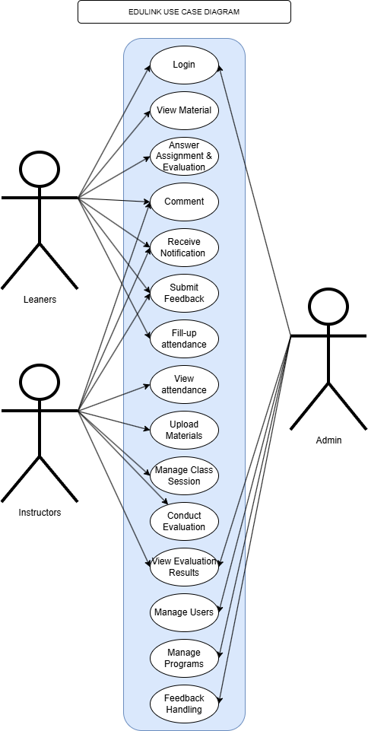
Figure 4. Use Case Diagram
Flowchart
Figure 5 shows the system flow of the Dual-Focus Intelligent System for Feedback Analytics and Beneficiary Performance Evaluation and details the interactions and available modules for each Beneficiary, Instructor, and Administrator. Beneficiaries can view materials, receive notifications, complete assignment or evaluation forms, record attendance, and submit feedback. Instructors share similar functionalities with Beneficiaries but also have additional features such as uploading materials, managing posts and comments, creating assignments and evaluation forms, viewing attendance, and submitting grades. Administrators have full system access, including managing users and programs, sending notifications, and resolving technical issues.
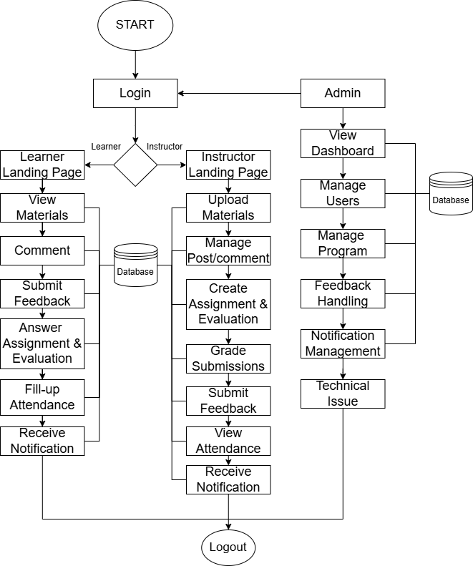
Figure 5. System Flowchart
Materials
Software
The Intelligent System for Feedback Analytics and Beneficiary Performance Evaluation would be developed using a full-stack web development approach to ensure scalability, maintainability, and responsiveness. The system would use Next.js (TypeScript) for both the front end and backend. This framework would enable seamless routing, server-side rendering (SSR), API creation, and static site generation (SSG), resulting in a dynamic yet performant application.
Frontend Development
The frontend of the system would be implemented using the following technologies:
Next.js (TypeScript): This framework handles the user interface and frontend logic, offering robust features such as SSR and dynamic routing.
Tailwind CSS: A utility-first CSS framework used to design a modern, responsive, and mobile-friendly user interface.
TanStack Query (formerly React Query): This library manages client-side state and asynchronous data fetching to keep the frontend in sync with the backend.
React-pdf: For opening a PDF file inside a system.
Additional Libraries and Tools: Supporting tools and libraries will be integrated as needed to enhance the user experience and interface functionality.
Backend Development
The backend would also be built using Next.js (TypeScript) through its API routes and serverless capabilities. The following tools and technologies would be utilized:
Prisma ORM: This tool would be used for database communication, providing a type-safe, efficient query interface.
PostgreSQL: An object-relational database system that would store and manage all structured data.
Socket.IO: Enables real-time communication for features such as messaging and notifications.
UploadThing: For storing files like PDF or other document formats and videos.
User Authentication and Communication
NextAuth.js: A flexible and secure authentication library for Next.js applications. It would handle user login, registration, session management, and third-party OAuth integrations (e.g., Google, GitHub).
Brevo: A reliable email delivery and communication platform. It would be used to send transactional emails such as account verification, password reset, and notifications.
Development Environment
Visual Studio Code (VS Code): It serve as the primary code editor due to its support for TypeScript, extensions, and developer productivity tools.
Containerization and Deployment
For scalable and cross-platform deployment, Docker would be considered for containerization. It would offer the following advantages:
Self-Hosting Capability: The system can be deployed on private or institutional servers, allowing organizations to maintain full control over data management, security, and system customization based on their specific operational requirements.
Device-Agnostic Accessibility: Docker would ensure consistent behavior across various environments and devices.
Streamlined Deployment: Through Docker, all dependencies would be packaged, simplifying the deployment process and reducing configuration errors.
Hardware
The laptop runs Windows 10 on a 64-bit operating system with an x64-based processor, 8GB RAM, and an Intel(R) Core(TM) i3-2384M CPU @ 2.30GHz 2.50 GHz.
Project Testing and Evaluation
In Project Testing and Evaluation, the researchers used different tests to build this project. Figure 6 shows that the researchers conducted evaluation and other testing, which are Unit Testing, Compatibility Testing, Integration Testing, System Testing, and Evaluation Procedure, to ensure the quality and reliability of the project.
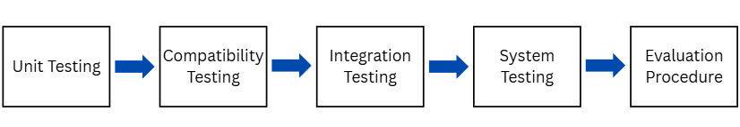
Figure 6. Project Testing and Evaluation
Unit Testing
Unit testing was conducted systematically on each module of the Extension Program Assessment system to ensure that individual components perform correctly and meet their respective specifications. Comprehensive unit testing would be performed on the Beneficiary Module, Instructor Module, Administrator Module, and Notification Module. Each module would undergo testing of its core functionalities, including: Beneficiary Module testing to verify the ability to view all posts, files, announcements, answer activities, and answer evaluations within enrolled programs; Instructor Module validation of material upload capabilities, Beneficiary management, grade submission, evaluation form release, and evaluation results viewing functions; Administrator Module testing of user management, program management, and feedback handling efficiency; and Notification Module confirmation that the system would successfully send real-time notifications for new materials, tasks, evaluations, and announcements. Any defects identified during unit testing would be promptly addressed and retested to confirm system stability and functionality integrity across all modules.
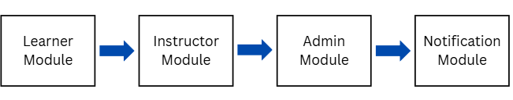
Figure 7. Unit Testing
Compatibility Testing
Compatibility testing would verify consistent system operation across multiple browsers and devices. Testing would cover Microsoft Edge, Firefox, Chrome, and Opera GX across key pages, including Login, Landing, Program, Administrator Dashboard, User Management, Program Management, and Feedback Pages. Evaluation would focus on rendering, performance efficiency, and accessibility compliance, ensuring Beneficiaries, Instructors, and Administrators can reliably access and use Extension Portal regardless of browser preference and inclusive access.
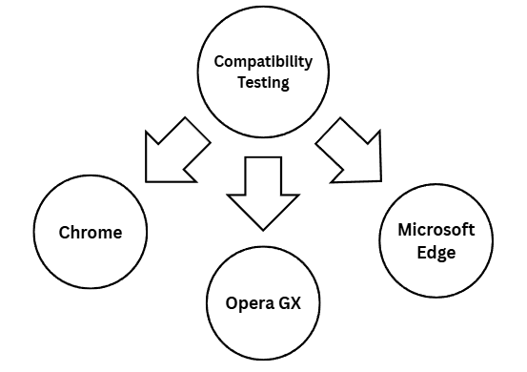
Figure 8. Compatibility Testing
Integration Testing
Integration testing was performed to validate seamless interaction and data flow between the different modules of the Extension Program Assessment system. The testing verified the data exchange and proper communication between the Beneficiary, Instructor, Administrator, and Notification modules. Integration testing confirmed that the expected output is produced correctly when modules interact with each other, and that system response times remain within acceptable parameters during inter-module transactions.
The integration testing would validate that the Beneficiary Module successfully provides Beneficiaries access to all program resources, the Instructor Module enables comprehensive course management and grading functions, the Administrator Module supports effective system administration, and the Notification Module reliably delivers timely communications.
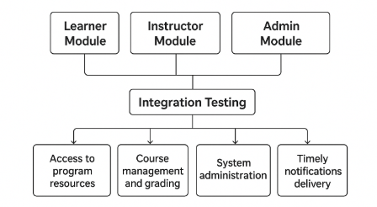
Figure 9. Integration Testing
System Testing
The researchers evaluated the system’s features based on the project objectives, testing each function to ensure that all components operate correctly and perform as intended. They documented their findings meticulously to provide a comprehensive overview of the system's performance. Additionally, feedback from users was incorporated to refine the system further and address any potential issues.
Evaluation Procedure
ISO 25010
The 5-point scale was used for verbal rating in the ISO survey was tool that gives a systematic and standard approach to rating compliance, effectiveness, and performance regarding ISO standards. The scale enables respondents to rate their opinions on a scale of quality, from Excellent to Poor. Rating 5, or Excellent, is a standard that reflects full compliance and highly efficient implementation of ISO standards, and rating 4, or Good, is satisfactory performance with some minor aspects that need improvement. Rating 3, or Fair, is acceptable yet averagely meeting ISO standards, implying a need for further improvement. Rating 2, or Need Improvement, focuses on some significant deficiencies that need corrective steps, and rating 1, or Poor, delivers poor performance and significant non-compliance.
Table 7. 5-point Verbal Interpretation Scale for ISO survey
Rating | Interpretation
5 | Excellent
4 | Good
3 | Fair
2 | Need Improvement
1 | Poor

Technology Acceptance Model
The verbal interpretation scale in Table 8, utilized in the TAM survey for measurement, consists of a 4-point scale that assesses the level at which the respondent agrees to statements regarding technology usefulness, ease of use, and acceptance. It prompts clear responses without the option of "neutral, hence offering better insight into users' attitudes. Ratings of 4 represent high acceptance and perceptions (Strongly Agree), 3 represents general approval (Agree), 2 reveal negative perceptions and denote disagreement, while 1 (Strongly Disagree) represents strong opposition and rejection of the statements. Overall, this rating scale helps grasp the levels of acceptance more effectively and enables the reliable analysis of the adoption of technology.
Table 8. 4-point Verbal Interpretation Scale for TAM survey
Rating | Interpretation
4 | Strongly Agree
3 | Agree
2 | Disagree
1 | Strongly Disagree
Population of the Study
The population of this study consists of two groups: (1) Beneficiaries, comprising 4Ps (Pantawid Pamilyang Pilipino Program) Beneficiaries, solo parents, senior citizens, PESO (Public Employment Service Office) clients, LGU representatives, and administrative faculty from the College of Computer Studies (CCS) who are engaged in educational and community development initiatives; and (2) IT expert. These participants collectively serve as the target users of the Intelligent System for Feedback Analytics and Beneficiary Performance Evaluation.
Table 9. Respondent of the Study
Type of Respondent | Number of Respondent
User | 56
IT Expert | 2
Data Collection Instrument
The data was gathered through a questionnaire and survey, which would directly impact the development and outcomes of the Intelligent System for Feedback Analytics and Beneficiary Performance Evaluation project. The developers would administer a questionnaire survey to respondents, including 4Ps Beneficiaries and faculty members, to collect essential data that would guide the construction of the web-based system. Specific questions were revolved around the web-based system’s design, user interface, accessibility, and its potential to support learning and community-based research and extension.
The application was evaluated through questionnaires assessing its functionality, design appeal, accessibility, mobile responsiveness, content relevance, and user interface familiarity.
Table 10. Likert Scale for TAM survey
Rating | Interpretation | Range
4 | Highly Acceptable | 3.25-4.00
3 | Moderate Acceptable | 2.50-3.24
2 | Slightly Acceptable | 1.75-2.49
1 | Not Acceptable | 1.00-1.74

To get the mean:
x̄ =$\frac{⅀ x }{n}$
X̄ = Mean
$⅀$ = sum of
$x$ = individual rating
$n$ = number of respondents

Statistical Treatment
For data analysis, the developers computed the mean of the survey responses to determine the central tendency. Each Likert scale option was assigned a numerical value, which was then aggregated for each question. The total was divided by the number of responses to obtain the average score. This quantifiable measure provided meaningful insights into the participants’ attitudes and perceptions. The mean scores were compared across different respondent groups to identify trends and variations in feedback. In addition to the mean, the developers calculated the Standard Deviation to see how much the answers varied from the average. This helped highlight questions with high disagreement or uncertainty among respondents. To make the numbers easier to understand, interpretation was applied using Highly Acceptable, Moderate Acceptable, Slightly Acceptable, and Not Acceptable to a specific range of scores. The analysis results were then visualized in charts and tables to support clear and actionable conclusions. These insights guided the refinement of the system’s features and user interface. Furthermore, they ensured that the final platform aligns closely with the needs and expectations of its users.
CHAPTER 4
RESULTS AND DISCUSSION
This chapter presents the results and the discussion to support the methodology utilized in the achievement of the objectives. The presentation is usually guided by the specific objectives or problems of the research study.
Results Based on the Objectives of the Study
1. Integrated system for Extension Program that manages both Beneficiaries activities and their performance evaluation.
Figure 10 shows the Login page of EduLink. On the Login page, Beneficiaries and Instructors can see the button to log in using Google.
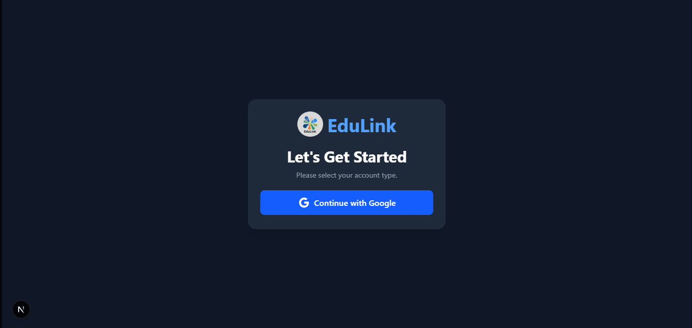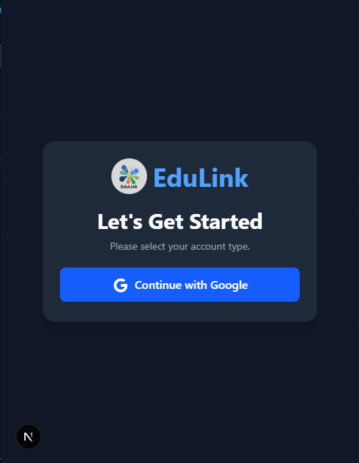
Figure 10. Login Page of EduLink on Web and Mobile
Figure 11 shows the landing page for the Beneficiaries. On the program page, the Beneficiaries can see all the existing programs. Every Beneficiaries can request to join in any program that they need to attend to. It is indicated on the upper right corner of every program, if you are already a member of that certain program or not.
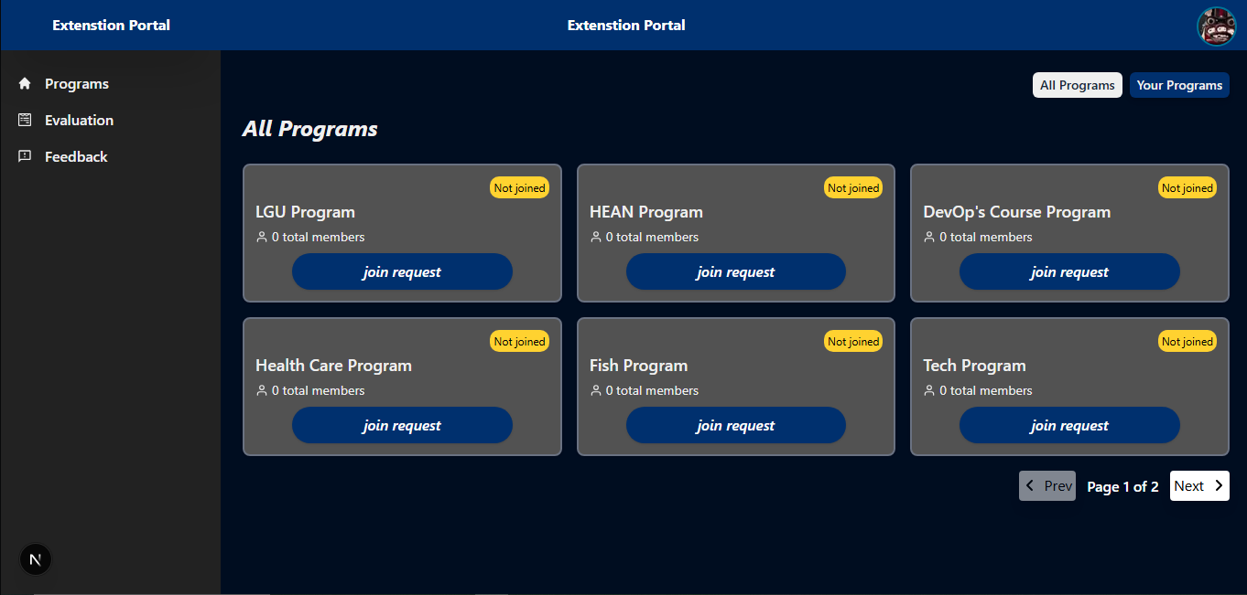
Figure 11. Landing Page of EduLink for Beneficiary
Figure 12 shows the program page for Beneficiaries, displaying all activities and resources within the selected program. It provides access to updates, assignments, meeting schedules, and member information.
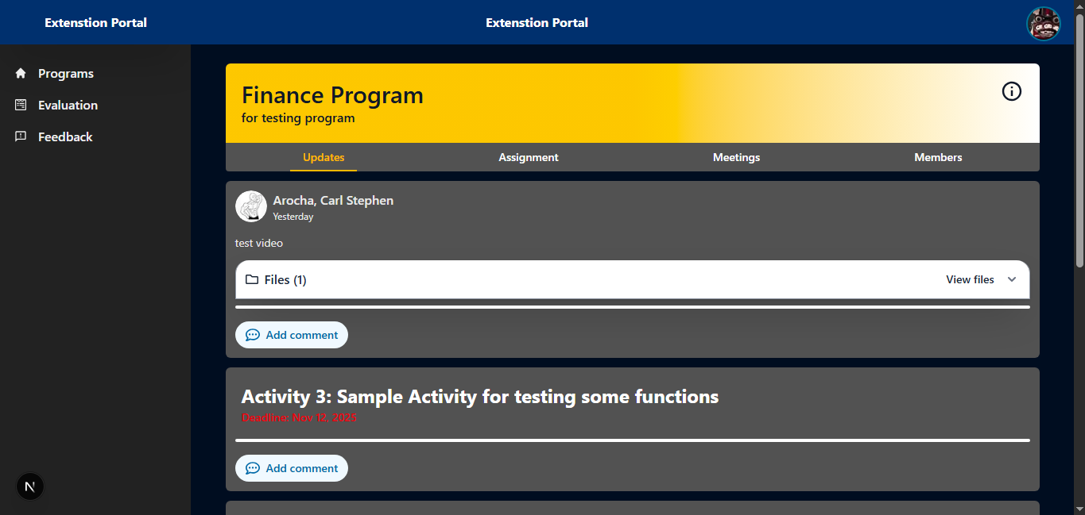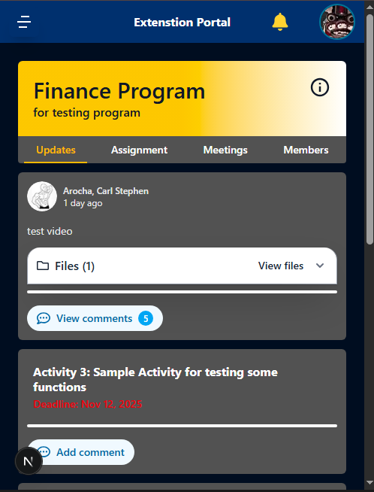
Figure 12. Program page for Beneficiary
Figure 13 shows the landing page for the Instructors. On the program page the Instructors can see all their existing programs.
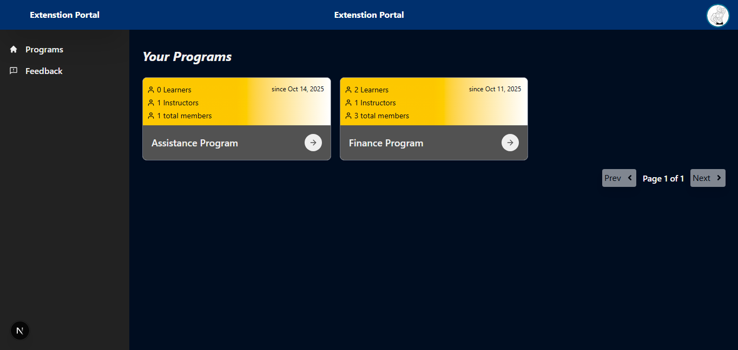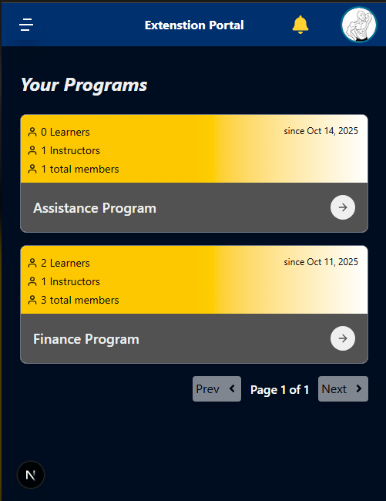
Figure 13. Landing Page of EduLink for Instructors
Figure 14 shows the program page for Instructors, displaying all activities and resources within the selected program. It provides access to updates, assignments, meeting schedules, and member information. This enables the instructors to efficiently manage all the Beneficiaries.
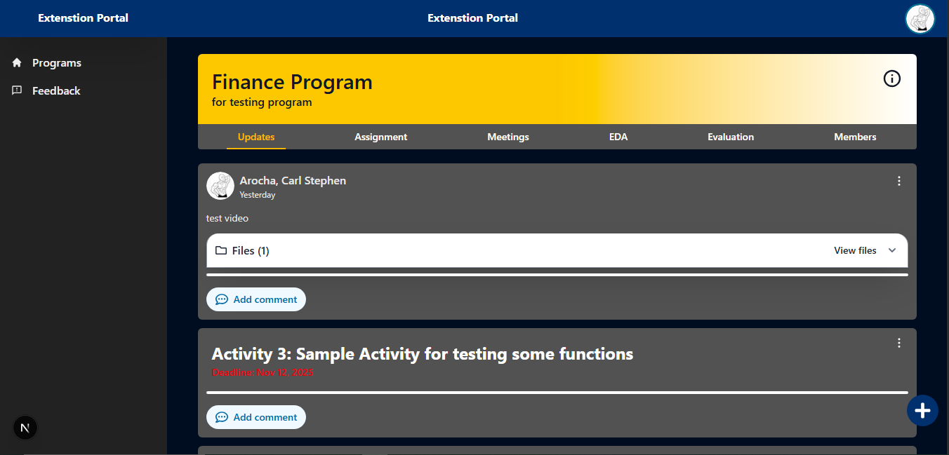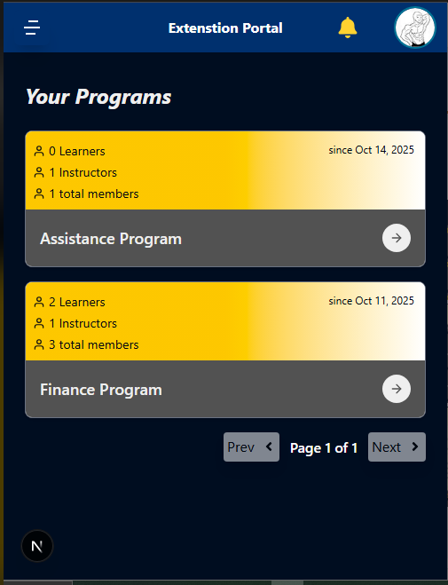
Figure 14. Program Page for Instructors
Figure 15 shows the Administrator dashboard. This page provides a summary of the system’s status. It shows the information for the existing programs, user roles, files uploaded, and active programs, displaying their engagement and activity.
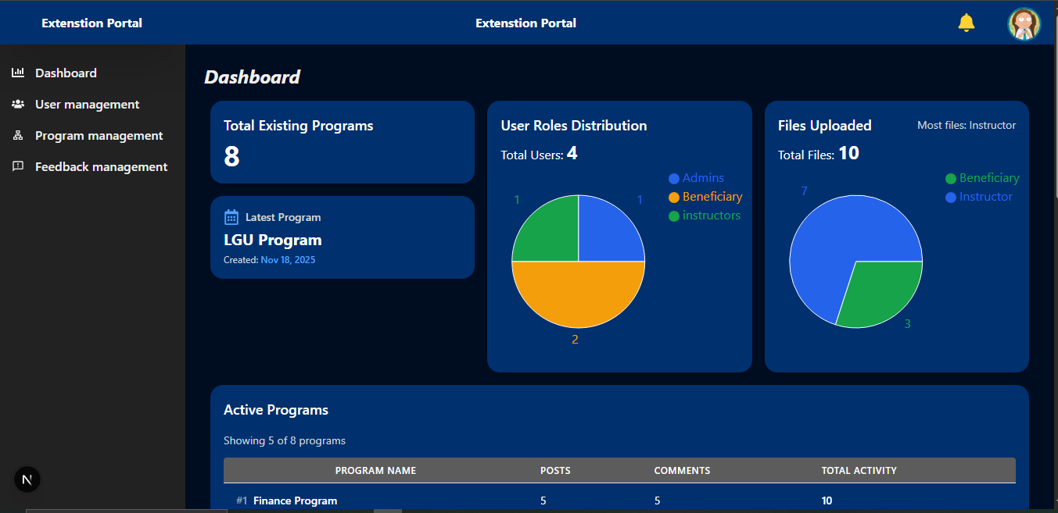
Figure 15. Administrator dashboard page
Figure 16 displays the User management. The Administrator can view the list of all system users' information and their assigned roles. It is crucial for performing administrative duties like checking user information, assigning different roles to users, and carrying out actions such as editing or removing user accounts.
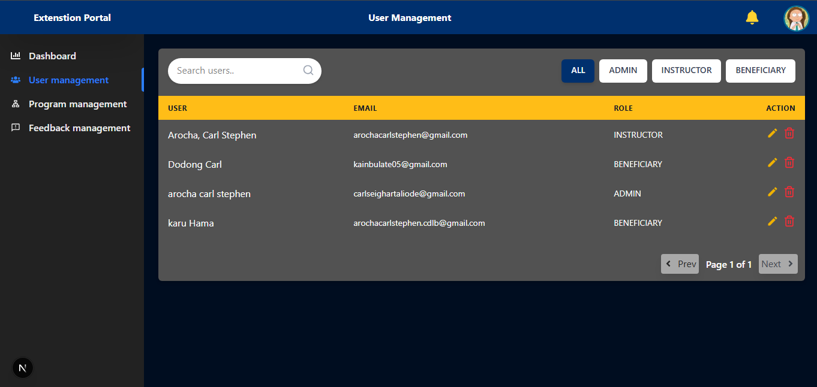
Figure 16. User management page
Figure 17 illustrates the program management page. On this page, the Administrator can view all existing programs. Each program displays the program title, creation date, and the total number of members in that program, along with their respective roles. The Administrator uses this page to manage programs and Instructors that facilitate those programs. It also allows the Administrator to organize and update program assignments to ensure smooth system operations.
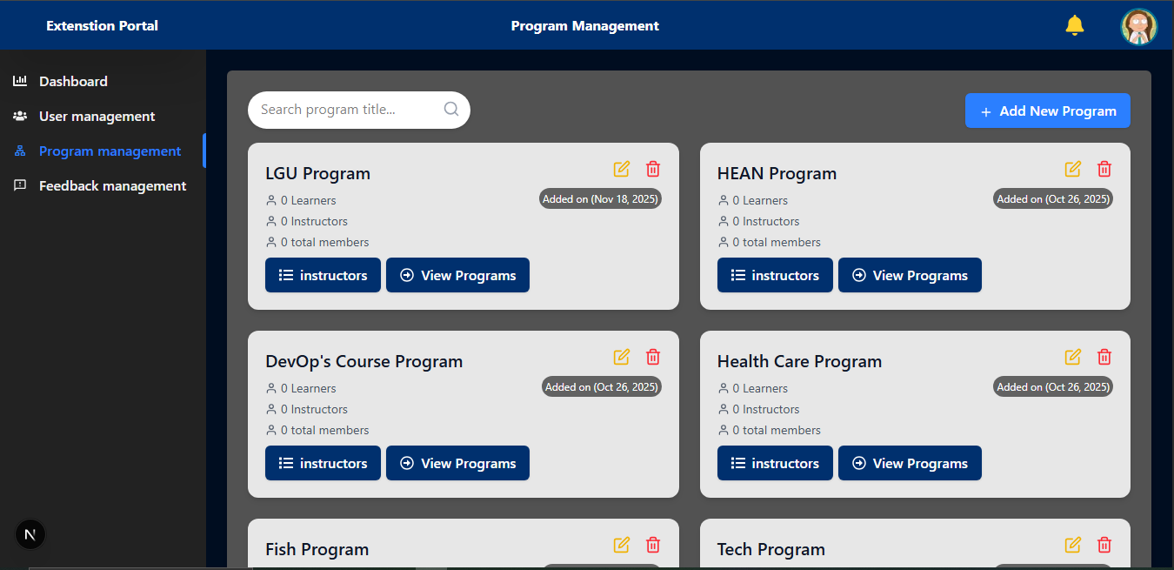
Figure 17. Program management page
Figure 18 shows the Feedback Management page. This page displays a list of submitted feedback entries, along with a summary of total feedback, differentiating between identified and anonymous submissions. Each entry details the program it concerns, the user's name if identified, and the submission date. This tool is essential for the Administrator to monitor user satisfaction, quickly identify areas for improvement, or determine if new features or fixes are needed for the Extension Portal.
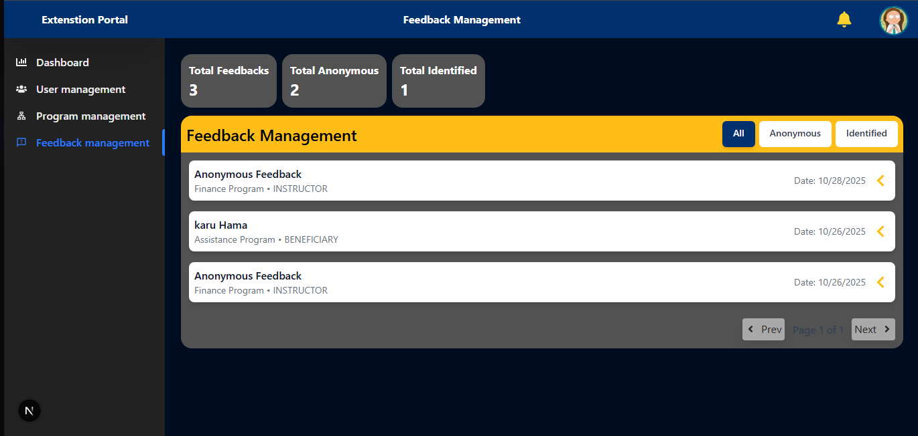
Figure 18. Feedback Management page
System Assessment using ISO 25010
Table 11 displays the product quality assessment of the system based on the ISO/IEC 25010 quality characteristics. Results show that most of the criteria, such as Functional Suitability, Usability, Security, Compatibility, Performance, Maintainability, and Portability, received excellent ratings. This indicates that the system effectively supports the needs of its intended users across multiple dimensions. Even though the Reliability is rated good, the overall composite mean of 4.56 demonstrates that the system meets the standards and delivers reliable, secure, and user-friendly functionality.

Table 11. Product Quality Assessment
Characteristic | Resp 1 | Resp 2 | Mean | SD | Interpretation
Functional Suitability | 4 | 5 | 4.5 | 0.71 | Excellent
Reliability | 4 | 4 | 4.0 | 0.00 | Good
Performance efficiency | 4 | 5 | 4.5 | 0.71 | Excellent
Usability | 5 | 4 | 4.5 | 0.71 | Excellent
Security | 5 | 4 | 4.5 | 0.71 | Excellent
Compatibility | 5 | 5 | 5.0 | 0.00 | Excellent
Maintainability | 5 | 5 | 5.0 | 0.00 | Excellent
Portability | 5 | 4 | 4.5 | 0.71 | Excellent
Composite Mean |  |  | 4.56 | 0.32 | Excellent
Legend: 5.00 - 4.20 Excellent, 4.19 – 3.40 Good, 3.39 – 2.60 Fair, 2.59 – 1.80 Needs Improvement, 1.79 – 1.00 poor
Result of Technology Acceptance Model
Table 12 shows the overall evaluation results of the system based on the Technology Acceptance Model. Each section consists of 5 items rated using a four-point Likert scale. The results show that all three categories achieve a mean score ranging from 3.56 to 3.59, which falls into the Highly Acceptable category. These findings indicate users find the system easy to navigate and operate.
Table 12. Technology Acceptance Model (TAM) Evaluation Results
Item | Number of Items | Mean | SD | Interpretation
Perceived Usefulness (PU) | 5 | 3.59 | 0.51 | Highly Acceptable
Perceived Ease of Use (PEU) | 5 | 3.56 | 0.56 | Highly Acceptable
User Satisfaction | 5 | 3.59 | 0.49 | Highly Acceptable
Legend: 3.25 – 4.00 = Highly Acceptable, 2.50 – 3.24 =Moderately Acceptable, 1.75 – 2.49 = Slightly Acceptable, 1.0 – 1.74 = Not Acceptable
Table 13 shows that Perceived Usefulness (PU), Perceived Ease of Use (PEU), and User Satisfaction (US) all received a “Highly Acceptable” rating, indicating that users find EduLink highly effective for content sharing, storage, and displaying evaluation data.
Table 13. Evaluation Results of survey answers
Item | Mean | Standard Deviation | Interpretation
Perceived Usefulness
1. The system helps reduce the time needed to conduct and process Beneficiary evaluations. | 3.66 | 0.48 | Highly Acceptable
2. The system provides a well-structured workflow for managing classroom activities, learning materials, and assessments. | 3.57 | 0.53 | Highly Acceptable
3. It improves the efficiency of monitoring Beneficiary performance after each session. | 3.64 | 0.48 | Highly Acceptable
4. The system improves the accuracy and reliability of collecting and analyzing Beneficiary feedback through evaluation form | 3.55 | 0.50 | Highly Acceptable
5. The system can adapt to changes in evaluation forms, class activities, and reporting requirements. | 3.54 | 0.54 | Highly Acceptable
Perceived Ease Of Use
1. The user interface design makes the experience easy and smooth. | 3.43 | 0.66 | Highly Acceptable
2. The features of the system are easy to understand and to use. | 3.59 | 0.50 | Highly Acceptable
3. The modules make it easy for the user to navigate and understand information. | 3.63 | 0.49 | Highly Acceptable
4. The evaluation results are easy to access for both Administrators and for the Instructors. | 3.70 | 0.46 | Highly Acceptable
5. Adjusting class details in the system is simple and manageable. | 3.45 | 0.63 | Highly Acceptable
User Satisfaction
1. The system provides all essential features needed for monitoring and evaluation. | 3.55 | 0.50 | Highly Acceptable
2. It produces accurate and reliable results. | 3.64 | 0.48 | Highly Acceptable
3. The system makes it easier for teachers to administer evaluations when needed. | 3.57 | 0.50 | Highly Acceptable
4. The system delivers meaningful insights and reports for monitoring progress. Through evaluation form | 3.57 | 0.50 | Highly Acceptable
5. I would recommend this system for full implementation in the extension program. | 3.61 | 0.49 | Highly Acceptable
Overall Mean | 3.59 | 0.65 | Highly Acceptable
Legend: 3.25 – 4.00 = Highly Acceptable, 2.50 – 3.24 =Moderately Acceptable, 1.75 – 2.49 = Slightly Acceptable, 1.0 – 1.74 = Not Acceptable
N=56
Unit Testing
The following findings were derived through analyzing the system's units, representing the functions of each module. The developers tested all modules to ensure the connecting modules were up to standard.
The Beneficiary module provides Beneficiaries with access to the program, learning materials, submission of activities, and commenting/replying in the system. The module also supports Beneficiaries in completing the evaluation form.
Table 14. Unit Testing for Beneficiary Module
Tested Case | Expected Output | Actual Output | Remarks
View Program | Beneficiaries can view all available and enrolled programs | The Beneficiaries can view all the programs and the one they were registered | Passed
View Learning Materials | The Beneficiary can view all uploaded files/videos | Beneficiary can view all files | Passed
Submit Assignment | Beneficiary can upload assignment | Beneficiary successfully upload their assignment | Passed
Take Evaluation | The Beneficiary can answer the evaluation survey after session | Beneficiary answers evaluation survey after every face-to-face session | Passed
Comment/Reply | The Beneficiary can comment and reply in the posts | Beneficiary can comment and reply in every post | Passed

Table 15 displays the result of unit testing for the Instructor module. Each component is tested to ensure every feature is working as intended, such as managing program-related activities, including posting updates, uploading learning materials, creating assignments, conducting evaluations, and handling learner requests. This also confirms that the system meets its requirements. The successful completion of these tests validates that the module is stable and ready for integration into the broader system architecture.
Table 15. Unit Testing for Instructor Module
Tested Case | Expected Output | Actual Output | Remarks
Post Updates | Instructor can publish updates of the program | Instructors can post updates about the program | Passed
Upload Learning Materials | Instructor can upload files for the program | The Instructors can upload files for the Beneficiaries to view | Passed
Create and Grade Assignment | Instructor can add activity with deadline and grade it | Instructors can give activity with deadlines and also grade it | Passed
Conduct Evaluation | Instructors will tell Beneficiaries to answer the evaluation form. | Instructors can remind Beneficiaries to fill in the evaluation form | Passed
View Evaluation Results | Instructor can view EDA chart | Instructor can view all data | Passed
Approve/Reject join request | Instructor can approve/rejects Beneficiaries who wish to access the program | Instructors can accept and rejects Beneficiaries to join the program | Passed

Table 16 shows that all functions are operating correctly. The features responsible for managing user accounts, overseeing programs, and reviewing system feedback performed exactly as expected during testing. By rigorously verifying these administrative capabilities, the testing process ensures that high-level management tools are both reliable and secure. These results confirm the Administrator module’s full control, ensuring smooth oversight of system activities and program content.
Table 16. Unit Testing for Administrator Module
Tested Case | Expected Output | Actual Output | Remarks
Manage Users | Administrators can add, edit, or remove user accounts. | Administrators can add, edit and remove user. | Passed
Manage Programs | Administrator can add, edit and delete program | Administrators can create, edit and delete program. | Passed
Feedback Management | Administrator can view user feedback to the system | Administrators can review all user feedback. | Passed
Table 17 shows the unit tests for the notification module, including the expected and actual outputs. The results show that the notification module is functional and has passed the unit testing. The test specifically verifies that automated alerts are successfully dispatched to both Beneficiaries and Instructors across various interaction types, such as posts, replies, and assignment submissions. Furthermore, the alignment between the expected and actual outputs demonstrates that the integration with Gmail is configured correctly, ensuring timely communication within the platform.
Table 17. Unit Testing for Notification Module
Tested Case | Expected Output | Actual Output | Remarks
Notification | Beneficiaries and Instructors are notified via Gmail if someone post, reply, submit assignment and answer evaluation. | Beneficiaries and Instructors are notified via Gmail | Passed
Compatibility Testing
Table 18 illustrates the system's performance with various browsers. Three browsers—Microsoft Edge, Chrome, and Opera GX—were used to test the system. Each web page was assessed using four primary metrics: SEO, performance, accessibility, and best practices. According to the results, Chrome outperformed the other browsers in terms of system performance, suggesting more seamless functionality and an overall better user experience. Interestingly, the Landing Page consistently received a perfect score of 100 in every testing category across all browsers. The system's cross-platform dependability was confirmed by the fact that all browsers maintained high standards, even though scores varied slightly between platforms.
Table 18. Compatibility Testing of the System
Browser | Web Page | Performance |  | Accessibility | Best Practice | SEO
Chrome | Login Page | 100 | 98 |  | 100 | 100
Chrome | Landing Page | 100 | 100 |  | 100 | 100
Chrome | Program Page | 99 | 94 |  | 100 | 94
Chrome | Admin Dashboard | 95 | 98 |  | 100 | 100
Chrome | Admin User Management | 100 | 96 |  | 100 | 100
Chrome | Admin Program Management | 100 | 90 |  | 100 | 100
Chrome | Feedback Management | 100 | 89 |  | 100 | 100
Microsoft Edge | Login Page | 100 | 98 |  | 100 | 100
Microsoft Edge | Landing Page | 100 | 100 |  | 100 | 100
Microsoft Edge | Program Page | 98 | 94 |  | 100 | 100
Microsoft Edge | Admin Dashboard | 97 | 98 |  | 100 | 100
Microsoft Edge | Admin User Management | 99 | 96 |  | 100 | 100
Microsoft Edge | Admin Program Management | 100 | 90 |  | 100 | 100
Microsoft Edge | Feedback Management | 100 | 89 |  | 100 | 100
Opera Gx | Login Page | 100 | 100 |  | 100 | 100
Opera Gx | Landing Page | 100 | 100 |  | 100 | 100
Opera Gx | Program Page | 99 | 94 |  | 100 | 100
Opera Gx | Admin Dashboard | 96 | 98 |  | 100 | 100
Opera Gx | Admin User Management | 100 | 96 |  | 100 | 100
Opera Gx | Admin Program Management | 100 | 89 |  | 100 | 100
Opera Gx | Feedback Management | 100 | 89 |  | 100 | 100
Integration Testing
Integration testing verified that the system's modules—including Beneficiary, Instructor, Administrator, and notification functions—work together seamlessly. The results confirmed successful synchronization across end-to-end workflows, such as content delivery, evaluation processing, and automated alerts. This process ensured that data flows accurately between components, maintaining consistent experience for all user roles. The test proves the platform operates cohesively to support structured learning, feedback collection, and real-time performance monitoring.
Table 19. Integration Testing for System Module
Tested Case | Expected Output | Actual Output | Remarks
Beneficiary Module | Beneficiaries can view all posts, files, announcements, answer activities, and answer evaluations in the enrolled program. | The system successfully displayed all programs, post, files, assignment, and evaluation. | Passed
Instructor Module | The system allows Instructors to upload materials, manage Beneficiaries, grade submissions, release evaluation forms, and view evaluation results | The system shows that the upload of materials, managing Beneficiaries, grade submissions, release evaluation forms, and view evaluation results were working, | Passed
AdministratorModule | The system allows Administrator to manage users, programs and feedback efficiently | The system shows control of the Administrator over the system is working successfully | Passed
Notification Module | The system sends real-time notifications for new materials, tasks, evaluations, and announcements. | The system shows that the notification module is working via sending notification through Gmail. | Passed

CHAPTER 5
SUMMARY, CONCLUSION, AND RECOMMENDATION
Summary
The Extension Program Assessment: A Dual-Focus Intelligent System for Feedback Analytics and Beneficiary Performance Evaluation was developed to modernize the delivery, monitoring, and evaluation of extension programs across various Beneficiary sectors. Guided by the Agile Scrum methodology, the project underwent iterative development phases where continuous feedback from Instructors, Beneficiaries, and Administrators contributed to system refinement and alignment with user needs.
A comprehensive Learning Management System (LMS) was created to centralize instructional materials, announcements, and course content, addressing issues of fragmented information and inconsistent material distribution. The system features a responsive and user-friendly interface accessible through both web and mobile devices, ensuring that Beneficiaries with varying levels of technological access can utilize the platform. To support the evaluation of face-to-face sessions, a built-in assessment module was integrated, enabling Instructors to administer digital evaluations and automatically generate results for administrative monitoring and Beneficiary performance tracking.
The system comprises four main modules: the Beneficiary Module for accessing learning resources and evaluations; the Instructor Module for managing content and assessments; the Administrator Module for program oversight
and report generation; and the Evaluation & Feedback Analytics Module for analyzing results to support decision-making.
For evaluation, ISO 25010 was used by IT specialists to examine system quality attributes such as functionality, usability, reliability, performance efficiency, and maintainability. Meanwhile, Beneficiaries and Instructors assessed the system using the Technology Acceptance Model (TAM), focusing on perceived usefulness, perceived ease of use, and intention to adopt the platform. Results from both evaluations demonstrate strong acceptance and confirm that the system performs effectively within its intended operational context.
Conclusion
The Extension Program Assessment System successfully met its objectives and demonstrated its potential to enhance the efficiency of extension program implementation.
1. Creation of a centralized LMS for course content and program information.
The system successfully established a comprehensive LMS that organizes learning materials, announcements, and program documentation into a single accessible platform. This addressed the previous problems of scattered resources and inconsistent content distribution. By combining these elements, the platform significantly reduced the time spent searching for information and ensured that all users had access to the most updated versions of course materials in real-time.
2. Development of an accessible and user-friendly interface across devices.
The platform’s responsive design ensures compatibility across smartphones, tablets, and desktop devices, allowing Beneficiaries to participate regardless of technological limitations. Its intuitive interface supports users with varying levels of digital literacy.
3. Integration of a built-in evaluation and feedback module for performance monitoring.
The digital evaluation system allows Instructors to administer assessments immediately after sessions, while Administrators benefit from automated analytics for tracking Beneficiary progress and program effectiveness. This eliminated delays associated with manual evaluations.
Recommendations
Based on the system evaluation results and key insights gathered from users and evaluators, the following recommendations are proposed to further enhance the performance, usability, and long-term sustainability of the Extension Program Assessment system:
1. Conducting structured training programs and workshops for Instructors, Administrators, and Beneficiaries is highly recommended to ensure proper utilization of the system’s features. These training sessions would help improve user familiarity, maximize system benefits, and reduce technical difficulties during implementation.
2. To safeguard sensitive information, strict data protection protocols should be implemented before deployment and cloud hosting. This includes securing learner records, evaluation results, and program documents, as well as ensuring encrypted data transfers, role-based access control, and compliance with institutional and national data privacy standards.
3. Rolling out the system to additional programs, departments, and partner communities is recommended to maximize its long-term value. Wider adoption would allow for broader data-driven insights, improved monitoring of program outcomes, and enhanced support for decision-making at the institutional level.
4. Continuous improvement is encouraged by integrating additional features requested by users, such as more detailed analytics dashboards, automated notifications, and expanded reporting tools. These enhancements would improve functionality and adaptability to evolving program needs.

References
Adjiovski, B., Bogatinoska, D. C., Ismajloska, M., & Malekian, R. (2024). Enhancing educational technology in lectures for school students with learning disabilities: A comprehensive analysis. SN Computer Science, 5(6). https://doi.org/10.1007/s42979-024-03049-z
Arcilla, R. A., Zafe, R. I., Tuplano, S. T., & Colleagues. (2025). Lived experience of solo parents nurturing young children seven years and below in Virac, Catanduanes. International Journal of Nursing & Health Science, 9(1), 21–30.
Ayeni, A. J. (2012). Assessment of principals’ supervisory roles for quality assurance in secondary schools in Ondo State, Nigeria. World Journal of Education, 2(1), 62–69. https://doi.org/10.5430/wje.v2n1p62
Bradley, V. M. (n.d.). Learning management system (LMS) use with online instruction. ERIC. https://eric.ed.gov/?id=EJ1286531
Dai, B., He, Y., & Peng, M. (2025). Enhancing resilience in single-parent family adolescents in China: A randomized controlled trial based on home–school collaborative intervention. BMC Public Health, 25(1).
De Oliveira, P. C., de Cunha, C. J. C., & Nakayama, M. K. (2016). Learning management systems (LMS) and e-learning management: An integrative review and research agenda. Journal of Information Systems and Technology Management, 13(2), 157–180. https://doi.org/10.4301/s1807-17752016000200001
Dote, B. B., & Garcia, N. P. (2025). Unveiling the experiences of beneficiaries with solo parents. European Journal of Education Studies, 12(8), 112–126.
Fernandez, L., & Olfindo, R. (2011). Overview of the Philippines’ conditional cash transfer program: The Pantawid Pamilyang Pilipino Program (Pantawid Pamilya) (Philippine Social Protection Note No. 2). World Bank Group. https://documents1.worldbank.org
Flores, M., Espinoza, C., Enrico, H., & Casimiro, R. (2019). Pantawid Pamilyang Pilipino Program (4Ps): Its effect on the academic performance of student-beneficiaries in Calaba National High School in the Philippines. Journal of Public Administration and Governance, 9(2). https://doi.org/10.5296/jpag.v9i2.14762
Gilbert, B. (n.d.). Online learning: Revealing the benefits and challenges. St. John Fisher University. https://fisherpub.sjf.edu/education_ETD_masters/303/
Goldhammer, R. (1969). Clinical supervision: Special methods for the supervision of teachers. Holt, Rinehart and Winston.
Kasim, N. N. M., & Khalid, F. (2016). Choosing the right learning management system (LMS) for the higher education institution context: A systematic review. International Journal of Emerging Technologies in Learning, 11(6). https://doi.org/10.3991/ijet.v11i06.5644
Kayalar, M. T. (2021). Perspectives of university students on the efficiency of synchronous and asynchronous learning. ERIC. https://eric.ed.gov/?id=EJ1308493
Li, K. C. (2018). The evolution of open learning: A review of the transition from pre-e-learning to the era of e-learning. ERIC. https://eric.ed.gov/?id=EJ1247658
Lopez, M., Fernandez, R., & Cruz, J. (2024). Surviving and thriving: Stories of single student-mothers in state universities and private colleges. Educational Management & Society Journal, 3(4), 88–102.
Lucero-Dueñas, G. F. (2025). Societal perceptions, legal frameworks, and lived experiences of solo parents in the Philippines. East Asian Journal of Multidisciplinary Research, 4(1), 55–70.
Lumsden, B. D. (1985). The older adult as beneficiaries. Hemisphere Publishing.
Maro, C. E., Estaras, C. A. D., Ermino, A. K. G., Lelis, M. J., & Barola, R. C. (2024). Level of difficulties of working solo parents in balancing work and child’s education. Jurnal Pendidikan Progresif, 14(3), 402–415.
Nguyen, T. (2015). The effectiveness of online learning: Beyond no significant difference and future horizons. Journal of Online Learning and Teaching, 11(2). https://jolt.merlot.org
Ogunsaju, S. (1983). Educational supervision: Perspectives and practices in Nigeria. University of Ife Press.
Organo, J. D. (2023). Impact of the Pantawid Pamilyang Pilipino Program on education, health, and nutrition status of beneficiaries in Quezon. https://doi.org/10.5281/zenodo.8025766
Peretomode, V. F. (1995). Principles and techniques of instructional supervision. In V. F. Peretomode (Ed.), Introduction to educational administration, planning and supervision (pp. 191–200). Joja Educational Research & Publishers.
Philippine Institute for Development Studies. (2020). Education sector performance and public spending in the Philippines. PIDS.
Raes, A., Detienne, L., Windey, I., & Depaepe, F. (2019). A systematic literature review on synchronous hybrid learning: Gaps identified. Instructional Science. https://doi.org/10.1007/s10984-019-09303-z
Shachar, M., & Neumann, Y. (2003). Differences between traditional and distance education academic performances: A meta-analytic approach. International Review of Research in Open and Distance Learning, 4(2). https://doi.org/10.19173/irrodl.v4i2.153
Shitindia, S. J. (2025). Single parenthood and streetism: The hidden struggles of street children and single parents. Social Sciences & Humanities Journal, 6(2), 145–159.
Simeon, R. K. (2021). 4Ps as poverty reduction tool: A macroeconomic level analysis. https://www.paressu.org
Tinmaz, H., & Lee, J. H. (2020). An analysis of users’ preferences on learning management systems. Education and Information Technologies. https://doi.org/10.1186/s40561-020-00141-8
Tus, J., Cruz, M., Espiritu, N., & Paras, N. (2021). Amidst the online learning modality: LMS usage and academic performance of Filipino students. https://doi.org/10.6084/m9.figshare.17151374.v2
UNICEF & World Bank. (2022). State of global learning poverty: 2022 update.
Varkey, T. C., et al. (2022). Asynchronous learning: Best practices for the 21st century. Journal of Research in Innovative Teaching. https://doi.org/10.1108/jrit-06-2022-0036
Viglione, G. (2020). A year without conferences? Nature. https://doi.org/10.1038/d41586-020-00786-y
Wayback Machine. (n.d.). LMS field guide. https://web.archive.org
Wikipedia. (2025, February 14). Learning management system. https://en.wikipedia.org/wiki/Learning_management_system
Wong, E. (2024). Rethinking free education: Why cost removal alone cannot ensure learning equity. Journal of Global Education Policy, 18(2), 145–162.
Zabolotniaia, M., Cheng, Z., Dorozhkin, E., & Lyzhin, A. (2020). Use of Moodle LMS for innovative policy implementation. International Journal of Emerging Technologies in Learning, 15(13). https://doi.org/10.3991/ijet.v15i13.14945
Zare, E. J. G., et al. (2023). Technological devices and digital competences during COVID-19. Sustainability, 15(11). https://doi.org/10.3390/su15118494
Zulfikar, A. F., et al. (2019). The effectiveness of online learning with facilitation method. Procedia Computer Science. https://doi.org/10.1016/j.procs.2019.11.096

APPENDICES

APPENDIX A
Figures

Conceptual Framework
Project Design

Use Case Diagram
Flowchart

APPENDIX B
Compatibility Result

Compatibility Testing

Chrome Lighthouse

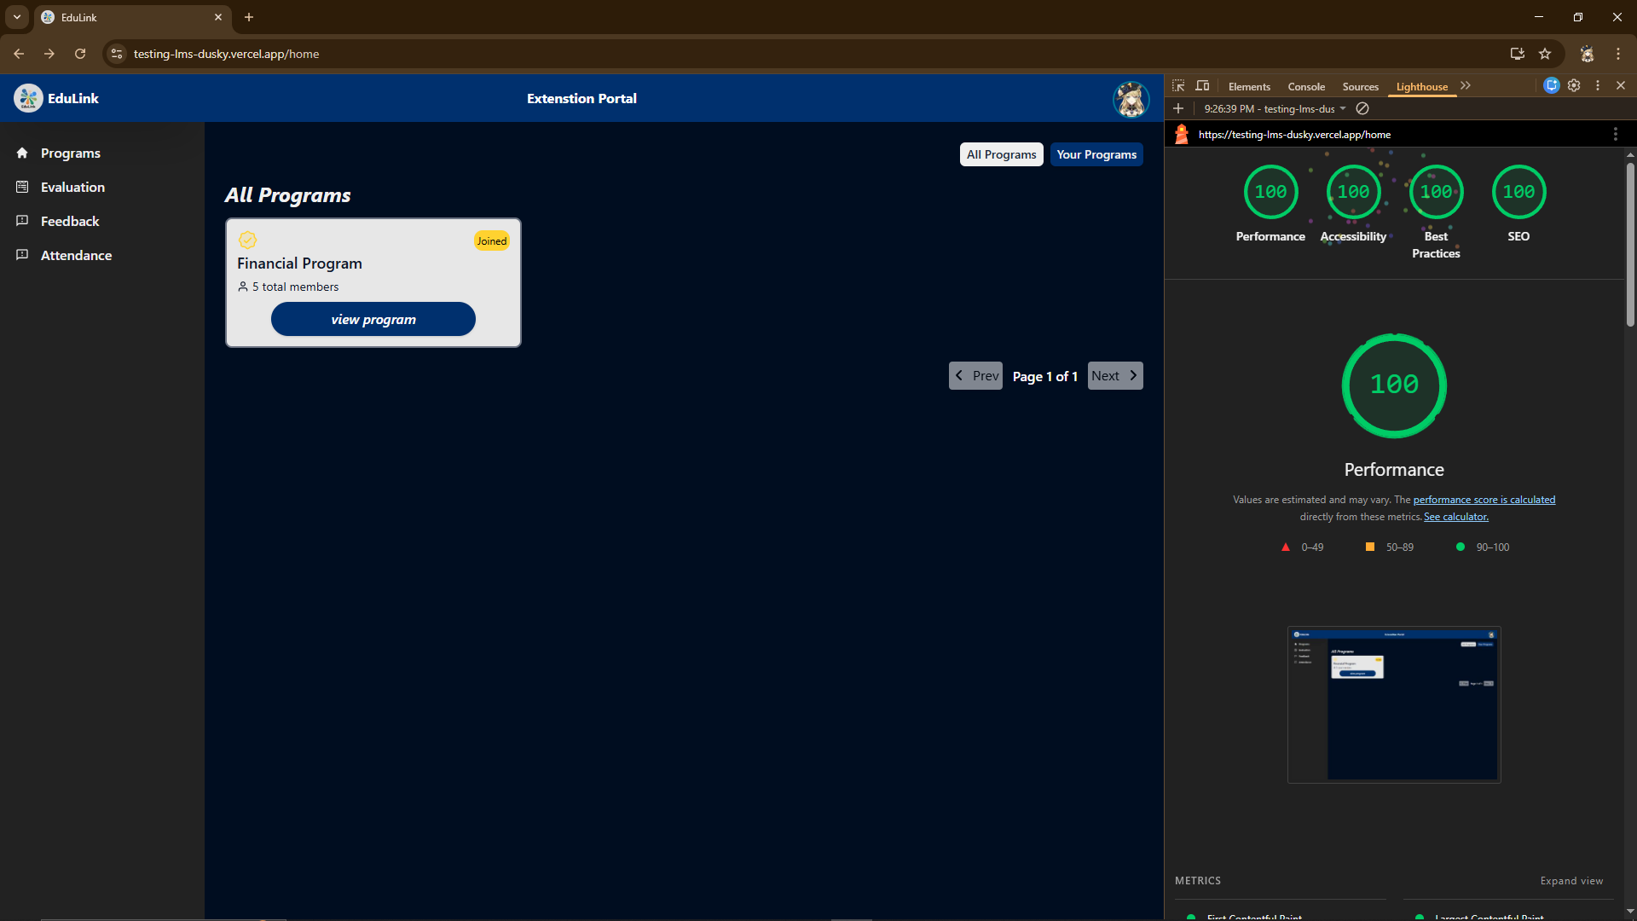
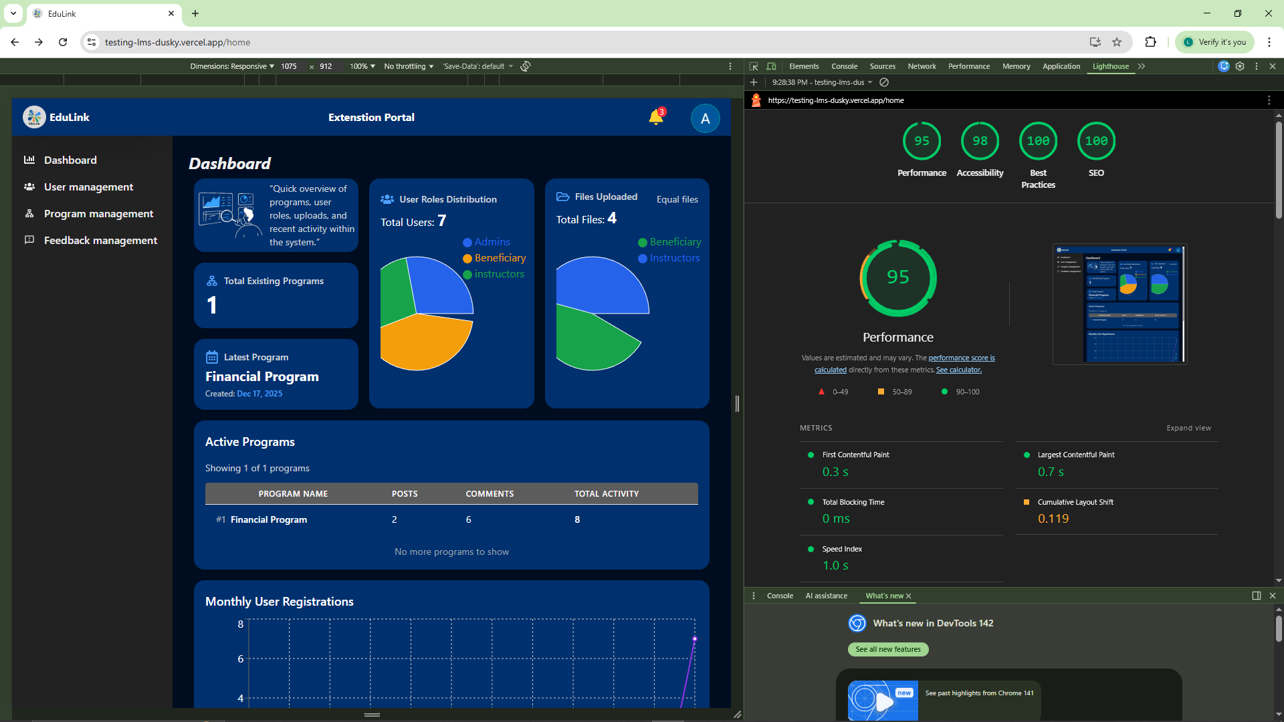

Microsoft Edge Lighthouse
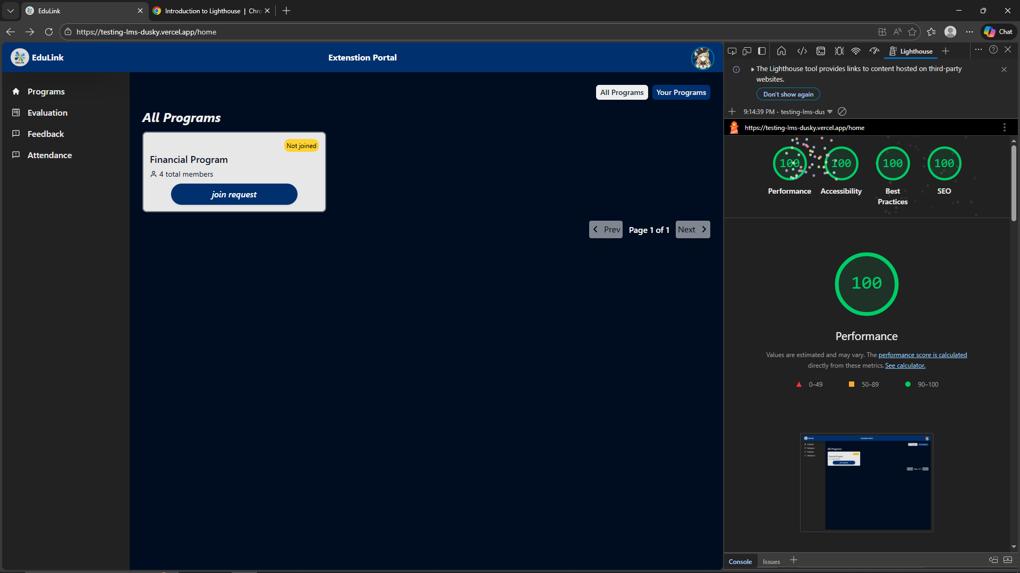
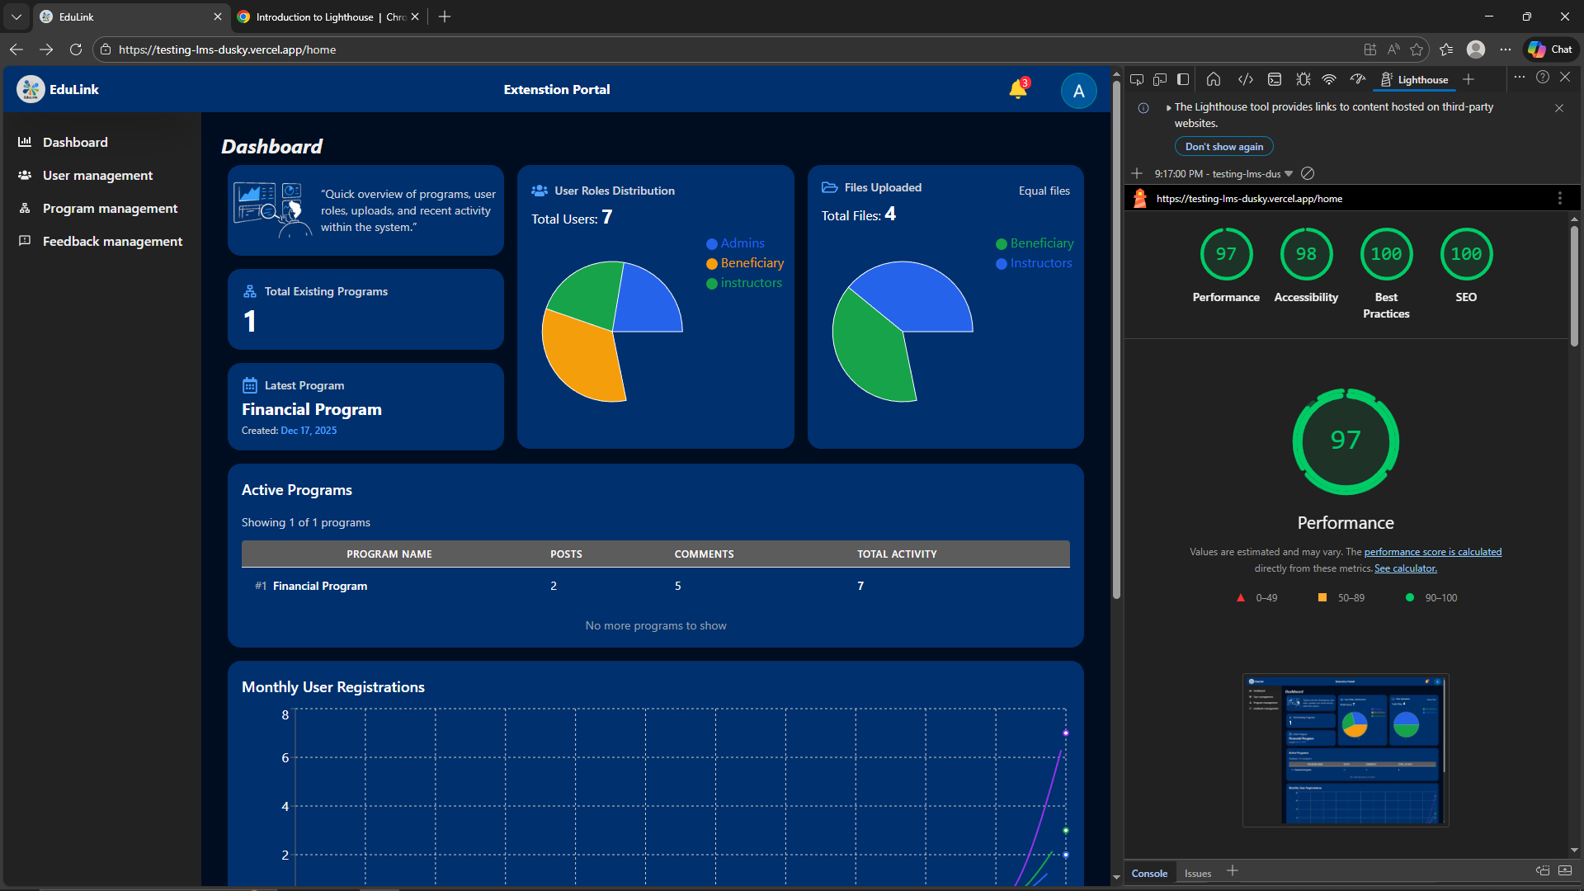

Opera Gx Lighthouse
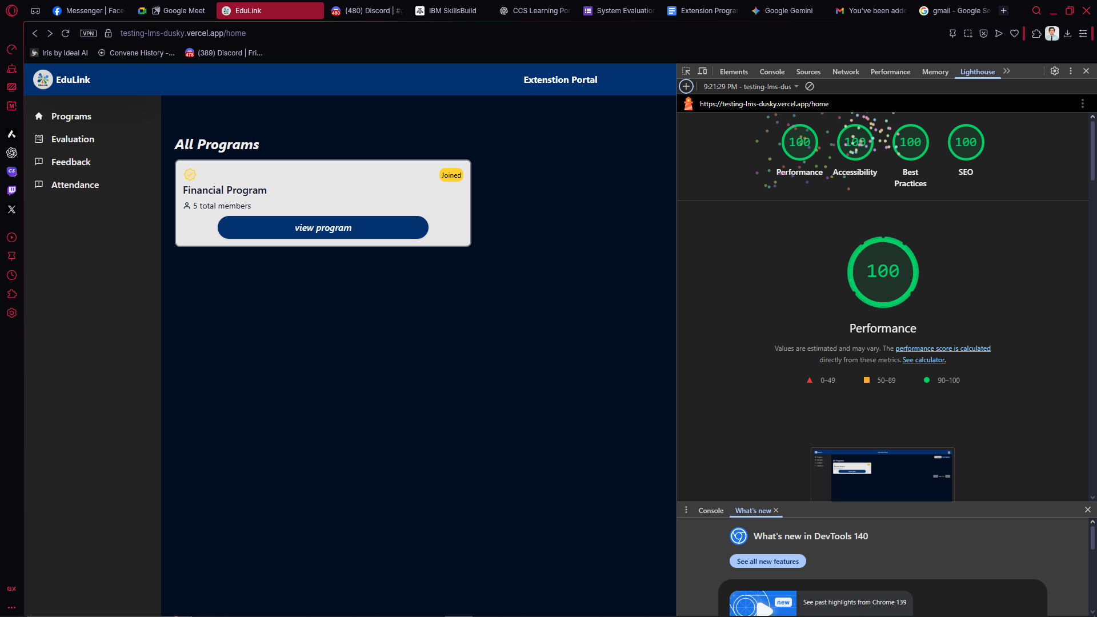
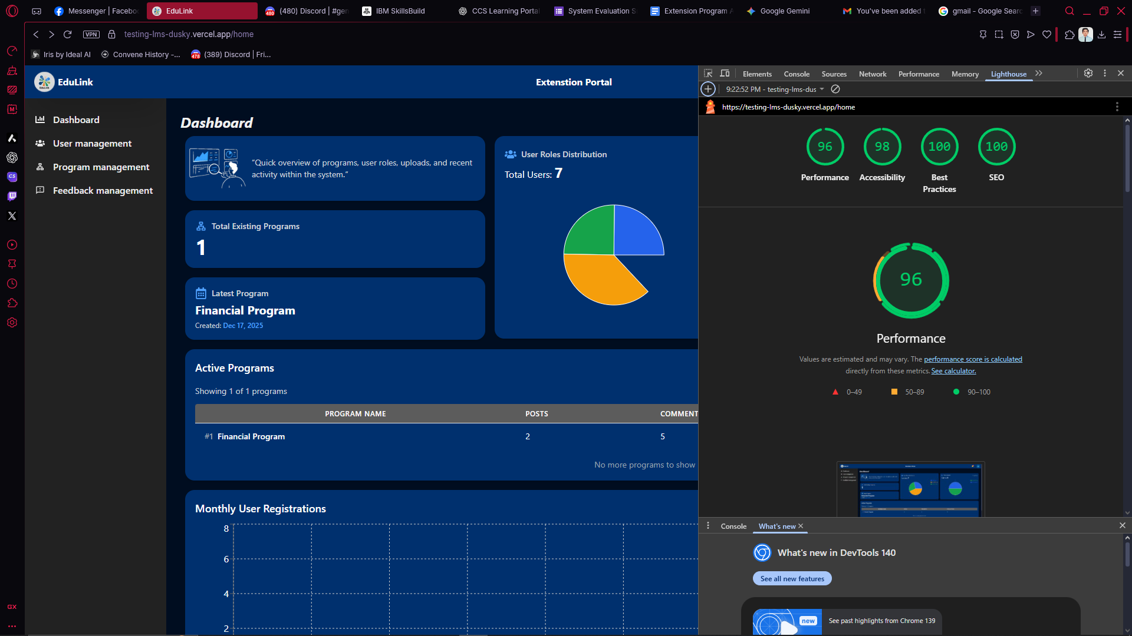

APPENDIX C
Survey Questionnaires

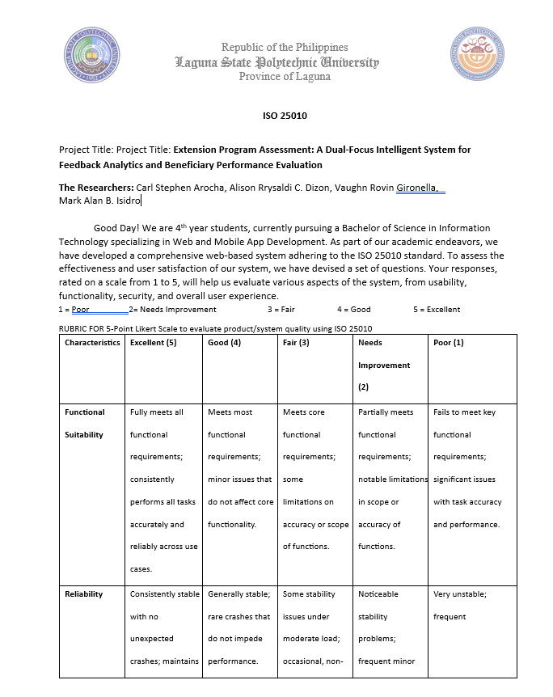
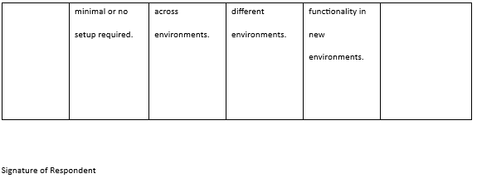
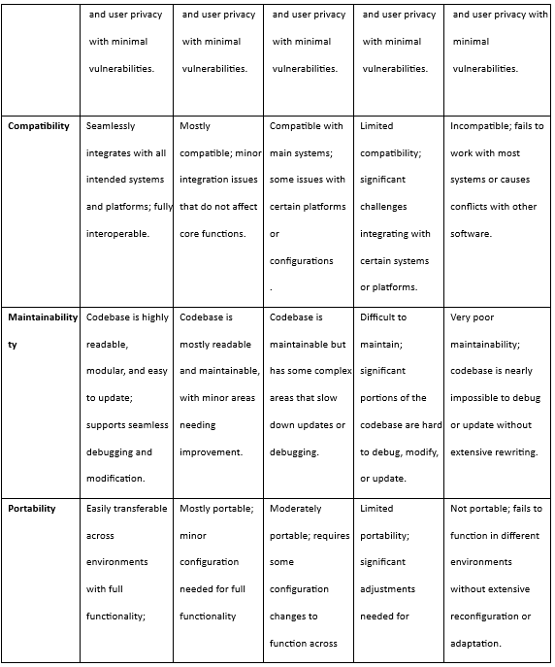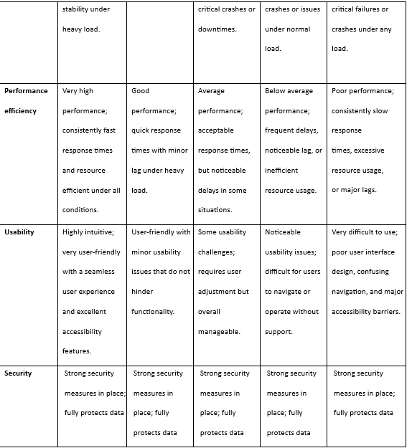

APPENDIX D
Grammarly Result

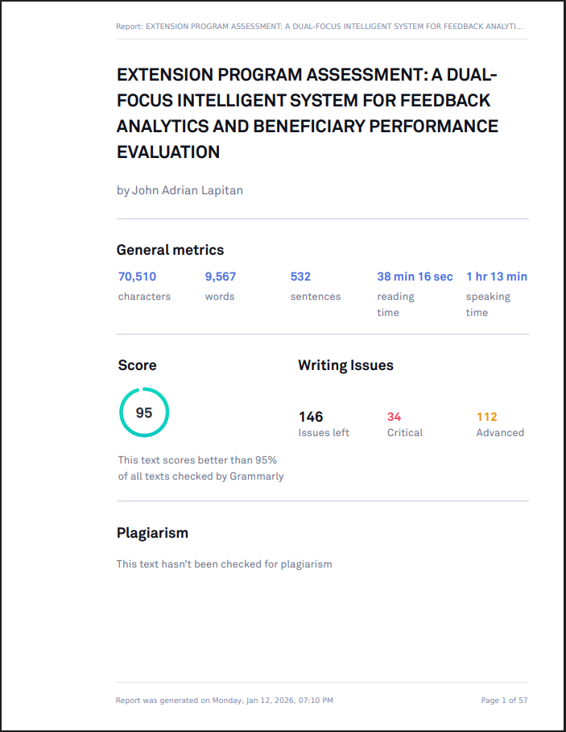

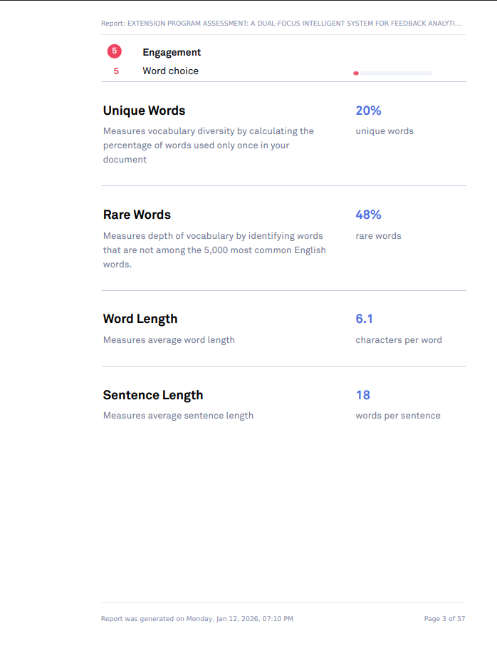

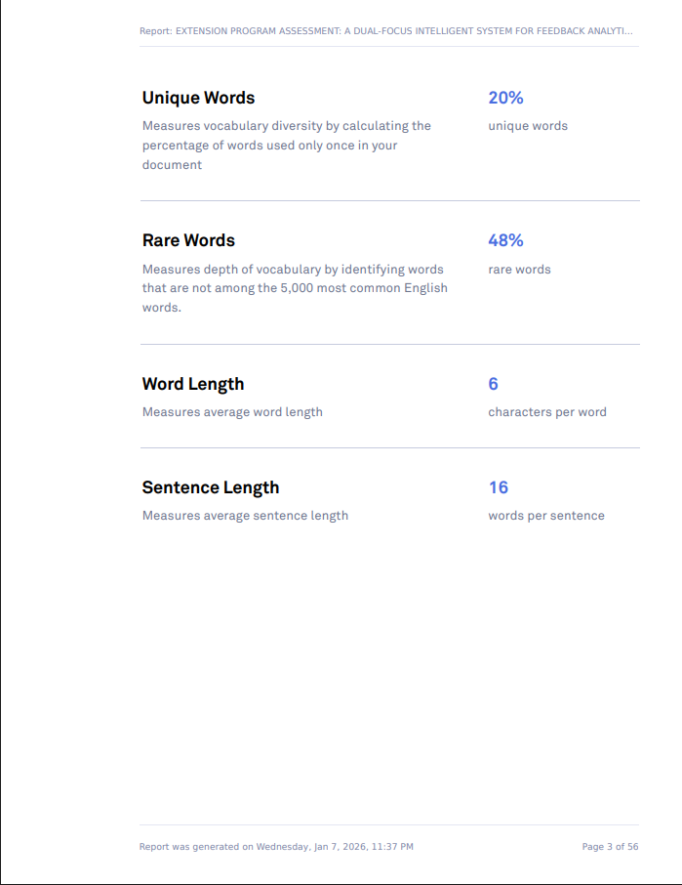

APPENDIX D
Turnitin Result

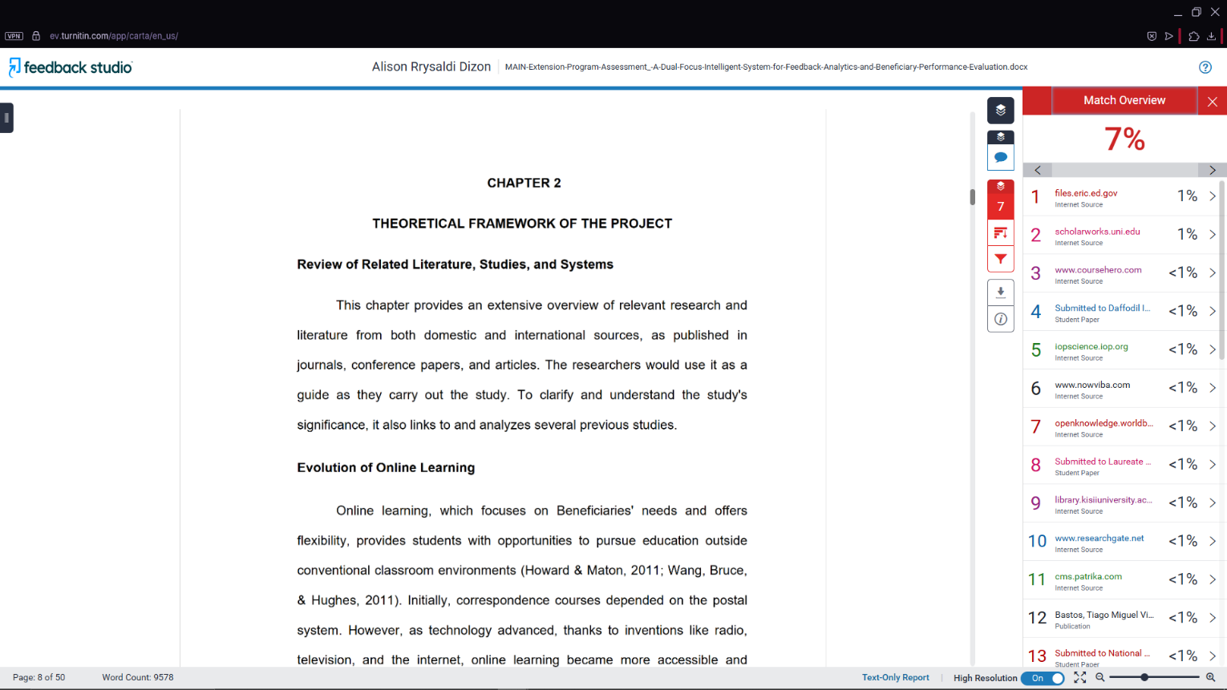
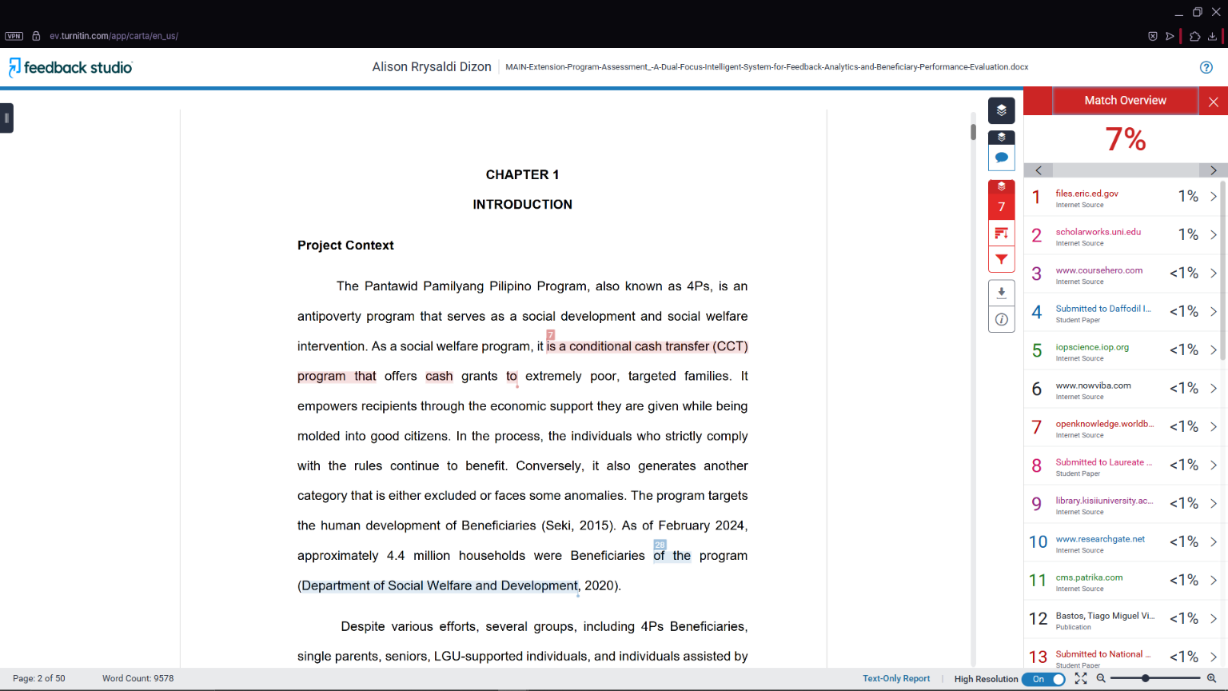

APPENDIX E
Publishable Paper

Extension Program Assessment: A Dual-Focus Intelligent System for Feedback Analytics and Beneficiary Performance Evaluation

Carl Stephen Arocha, Alison Rrysaldi C. Dizon, Vaughn Rovin Gironella, Mark Alan B. Isidro, Maribel V. Cardona
College of Computer Studies (CCS), Laguna State Polytechnic University, Los Baños, Laguna, Philippines
Article Info |  | ABSTRACT
Article history: |  | This system was developed to address the persistent problems faced by 4Ps beneficiaries, solo parents, seniors, LGU-assisted participants, and PESO-supported individuals in accessing quality educational support. Existing learning and evaluation processes rely on outdated, fragmented, and paper-based methods, which lead to inconsistent information delivery, delayed feedback, limited access to updated resources, and difficulty in tracking Beneficiary progress. To solve these issues, the system aims to provide a unified digital platform that modernizes information dissemination, streamlines evaluations through digital forms, centralizes data analytics, and functions as a Learning Management System (LMS). By doing so, it ensures that educational sessions become more organized, accessible, timely, and efficient for both Instructors and Beneficiaries.
Keywords:

Intelligent Feedback System
Beneficiary Performance Evaluation
Hybrid Learning Support
Digital Evaluation System
Educational Data Analytics
Learning Portal

Corresponding Author:
Carl Stephen Arocha, et al.
College of Computer Studies,
Laguna State Polytechnic University,
Malinta, Los Baños, Laguna, Philippines, 4030
Email: carlseighartaliode@gmail.com

I. INTRODUCTION
The Pantawid Pamilyang Pilipino Program, also known as 4Ps, is an antipoverty program that serves as a social development and a social welfare intervention. As a social welfare program, it is a conditional cash transfer (CCT) program, offering cash grants to extremely poor targeted families. It empowers recipients by the economic support they are given while being molded into being good citizens. In the process, the individuals who strictly comply with the rules keep on benefiting. Conversely, it also generates another category that is either excluded or face some anomalies. The program targets the human development of beneficiaries (Seki, 2015) [1]. As of February 2024, approximately 4.4 million households were the program's beneficiaries (Department of Social Welfare and Development, 2020).[2] Despite various efforts, several groups, including 4Ps beneficiaries, single parents, seniors, those supported by LGUs, and individuals assisted by PESO, continue to struggle to get the educational support they need. This includes quality learning materials, structured orientation programs, and dependable instructional guidance. The current methods of information dissemination, relying on outdated infrastructure and traditional teaching approaches by institutions and community facilitators, are simply not effective. The absence of a unified digital platform further complicates matters, leading to inconsistent learning processes, limited access to up-to-date resources, and insufficient tracking of Beneficiary engagement. Moreover, the continued use of paper-based assessments causes delays in data processing, increases the likelihood of errors, and makes it difficult to properly store and analyze feedback. The system is proposed to solve these problems. Through features such as digital forms, online feedback and centralised analytics. Additionally, the system will serve as an LMS, allowing Instructors to upload learning materials, organise sessions and track beneficiaries' progress. This initiative helps improve the educational accessibility of 4Ps Beneficiaries, solo parents, seniors, LGU and PESO participants. Instead of using paper evaluation forms, which are harder to store and slower to progress, the system allows Instructors to conduct digital evaluations. Beneficiaries can answer these assessments after every face-to-face session inside the system. This ensures Instructors remain in their learning sessions face-to-face, all evaluation, feedback, and resource management become organised, timely, and accessible.

Objectives
The primary goal of this research is to develop an education monitoring and feedback system that enhances the delivery and evaluation of extension programs for local beneficiaries. Specifically, the project aims to:
- Create an extensive Learning Management System (LMS) to store course content, announcements, and offer a centralized repository for all course information.
- Create an easy-to-use interface that is accessible on different devices (web and mobile), making it accessible regardless of technology that they have.
- Integrate a built-in evaluation and feedback module that allows Instructors to conduct assessments for beneficiaries directly within the system after every face-to-face session while enabling Instructors and Administrators to view and analyze the results for monitoring and performance evaluation

II. RELATED WORKS
Online learning, which focuses on the needs of learners and offers flexibility, provides students with opportunities to pursue education outside of conventional classroom environments [3]. Initially, correspondence courses depended on the postal system. However, as technology advanced thanks to inventions like radio, television, and internet online learning became more accessible and interactive. These findings highlight the significance of integrating technology into education, as they help learners to adapt to various learning options. This study highlights the several advantages and challenges of online learning. The advantage of working at your own pace is a major advantage allows the student to focus their time on more difficult activities . However, this flexibility also presented challenges, including the difficulties of time management, balancing meeting deadlines, unreliable internet access, and some students lacking home internet and needing to go to libraries or computer café. Despite all these challenges the ability to use online resources and work at your own pace was seen as a valuable aspect of online learning [4].
Students with learning disabilities have shown great potential in improving their academic results using educational technology, especially mobile applications. The effectiveness of the mobile app in screening for different learning disabilities such as dyslexia, dyscalculia, ADHD, and auditory processing disorder (APD) was effective [5]. The app shows promising results in students' academic performance after the usage of the app and shows excellent accuracy in identifying these disabilities. Therefore educational technology can be use for students who find it difficult to learn in standard settings.
For almost 30 years, learning management systems have been a component of the e-learning ecosystem. One of the few e-learning-related developments that have persisted to this day is learning management systems (LMSs). Learning management systems served as the focal point for all online learning activities during the first ten years of adoption of e-learning. A learning management system (LMS) is a software application for the administration, documentation, tracking, reporting, automation, and delivery of educational courses, training programs, materials, or learning and development programs. It is designed to replicate the real teaching and learning process, providing students with access to learning materials 24/7 at their own convenience. The basic description of an LMS is a software application that automates the administration, tracking, and reporting of training events. [6] the basic description of LMS is a software application that automates the administration, tracking, and reporting of training events.
Recent studies have highlighted the challenging educational realities that single parents and their children endure. [7] found that structured home-school collaborative interventions assist students from single-parent households by dramatically improving their resilience, emotional control, and goal concentration. This emphasizes the critical role that educators play in collaborating with single parents to support children's socioemotional learning. To support this viewpoint, [8] discovered that working solo parents have moderate to high difficulties balancing career responsibilities with their children's educational needs, particularly in terms of attending school activities and giving consistent academic support. These limitations are frequently caused by time restrictions, budgetary constraints, and a lack of institutional capacity. Learners also describe specific challenges associated with single parenthood. [9] discovered that adolescents raised by single parents usually struggle with emotional burdens, financial stress, and a desire for parental presence, but they also demonstrate resilience and empathy characteristics that impact their academic behaviors and school participation.
Uncontrollable emergency scenarios can shift teaching methods and impact the sustainability of higher education institutions. Such unforeseen circumstances necessitate quick involvement by institutional monitoring and input, which is, in many respects, a shared obligation. However, as the process requires work at the managerial level from the very beginning, Address the relevant issues. In a study conducted by [10] 60 principals and 540 teachers were randomly selected to assess the efficiency of principle supervision of teachers' instructional tasks. Secondary schools in Nigeria's Ondo State. [10] presented numerous monitoring approaches based on [11] and [12].
Armed with knowledge of the demographics of the senior population and the fallacies linked with the aging process, a clearer understanding of the value of education for our elderly has emerged. Acceptance of the principles and concepts of lifelong learning is linked to a higher emphasis on sustaining educational goals throughout one's life. There are three types of education for the elderly: 1) programs with particular privileges for seniors; 2) existing programs adapted or modified to meet the special needs of seniors; and 3) programs established and offered specifically for seniors [13].

III. METHODOLOGY
This chapter discussed the methodology and all the techniques that had been used in the research. Researchers in this topic use a systematic approach to fulfill their goal. To direct their work on the project, researchers use different strategies. It illustrated the database, hardware, software, and data gathering.

Project Design
Figure 1. System Architecture

The architecture of the Intelligent System for Feedback Analytics and Beneficiary Performance Evaluation is purposefully designed to support multifaceted educational outreach targeting 4Ps beneficiaries, solo parents, and senior citizens across designated locales. The system comprises three principal subsystems: the User Interface, the Admin Interface, and a centralized Database, cohesively integrated within a web-based platform enabling Learning Management and synchronous communication.
The User Interface serves as the gateway for both Beneficiaries and Instructors. Beneficiaries students, parents, and seniors utilize this portal to access educational materials (including documents and multimedia resources), engage in interactive forums, receive real-time notifications, and complete digital assessments. Instructors are provided with extended capabilities to upload learning materials, assign and grade tasks, provision evaluation forms, and orchestrate session schedules. This interface incorporates responsive technologies to facilitate seamless access across diverse devices, thereby bridging gaps in digital literacy and device availability.
The Administrator Interface is tailored to the requirements of system Administrators who supervise the operational integrity of the platform. Administrators exercise control over account management (for both beneficiaries and Instructors) and oversee the monitoring of system activities based on audit trails and usage reports. Their responsibilities include troubleshooting technical issues, maintaining secure records, and ensuring sustained system reliability—all vital for the continuous and efficient delivery of educational services.
At the core is the Centralized Database, functioning as the principal repository for all transactional and non-transactional data. It permanently stores user profiles, educational content, schedules, log files, discussion threads, and generated reports essential for feedback analytics and performance evaluation. Both the User and Administrator Interfaces dynamically interact with the database, facilitating real-time retrieval, update, and analysis processes. Data security and integrity are paramount, ensuring confidentiality while enabling evidence-based monitoring and program assessment.

Project Development
The development would begin with the Planning and Requirements Gathering phase, where the team would define the system’s core features, user roles, functional modules, and overall architecture. This stage involves consultations with faculty, technical experts, and community representatives to identify both educational and extension-related needs. Next, in the Design phase, wireframes for each user interface would be created, along with the system’s database schema and visual UI mockups. These visual assets would guide the actual coding and interface development.
The Development phase would involve building the platform using modern web technologies such as Next.js with TypeScript for both frontend and backend logic, Tailwind CSS for responsive and customizable design, and PostgreSQL as the main database system. During this phase, real-time communication (via Socket.IO).
Once core functionalities are in place, the Testing phase would commence. This would include unit testing of individual components, API testing to verify backend responses, integration testing to ensure modules work together, and User Acceptance Testing (UAT) to validate the system from the end-user’s perspective. After thorough testing, the system would enter the Deployment phase, using Docker to containerize the application for efficient self-hosting, scalability, and access across multiple devices.
Finally, during the Evaluation phase, the system would undergo usability and performance testing. Feedback from pilot users, including faculty and 4Ps participants, would be gathered to identify any issues and opportunities for improvement. These insights would guide future updates and ensure that the system continues to evolve in alignment with its educational and community objectives.

Agile Scrum
Software development methods like Agile Scrums prioritize flexibility, collaboration and gradual progress. By breaking up the development into small sprints, it helps ongoing system testing, feedback and enhancement generate a well developed software.
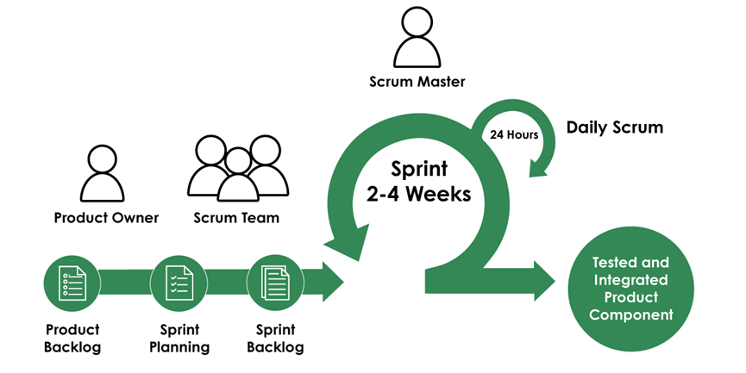
Figure 2. Agile Scrum

The Agile Scrum methodology is suitable for our system, which has role-based access, interactive features, and real-time changes in our system. Beneficiaries can read documents, leave comments, log in, and get notifications, while the admin focuses on the access control, overseeing material and regulating interactions. This methodology enables gradual development and focuses on the features like access control, authentication and managing materials. This adaptability enables adjustment in user input, assuring that the system satisfies Beneficiary requirements. Agile methodology lowers errors and enhances the quality of the system, making it productive and flexible for future improvement within an accessible platform.

Evaluation Procedure
To measure the system's software quality, an evaluation based on the TAM standard would be conducted. This assesses the system across eight quality characteristics: functional suitability, performance efficiency, compatibility, usability, reliability, security, maintainability, and portability.

Data Collection Instrument
The data would be gathered using a questionnaire and survey that would have a direct impact on the development and outcomes of the Intelligent System for Feedback Analytics and Beneficiary Performance Evaluation project. The respondents, including 4Ps beneficiaries and faculty members, would be given a questionnaire survey by the developers to collect essential data that would guide the construction of the web-based system. Specific questions would revolve around the web-based system’s design, user interface, accessibility, and its potential to support learning and community-based research and extension.
The evaluation of the application would be carried out by distributing questionnaires to the identified respondents. The questionnaire would consist of items focusing on the application's functionality in meeting the needs of its users, including design appeal, accessibility, mobile responsiveness, content relevance, and user interface familiarity.

Statistical Treatment
For data analysis, the developers computed the mean of the survey responses to determine the central tendency. Each option on the Likert scale was assigned a numerical value, which was then aggregated for each question. The total was divided by the number of responses to obtain the average score. This quantifiable measure provided meaningful insights into the participants’ attitudes and perceptions.

IV. RESULTS AND DISCUSSION
This chapter presents the results and the discussion to support the methodology utilized in the achievement of the objectives. The presentation is usually guided by the specific objectives or problems of the research study.

Results by Objectives of the Study
1. To create an integrated system for Extension Program that manage both beneficiaries activities and their performance evaluation.
Figure 3 shows the web and mobile view of the login page of EduLink . This allows both Instructors and learners to login their account using their personal gmail account to access the system.
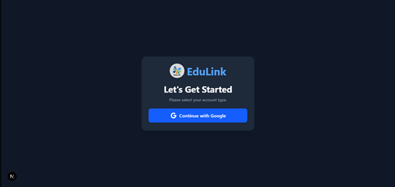
Figure 3. Login Page of EduLink on Web and Mobile

Figure 4 shows the landing page of the learners. On the program page, learners can see the programs they can request to join and their existing programs.
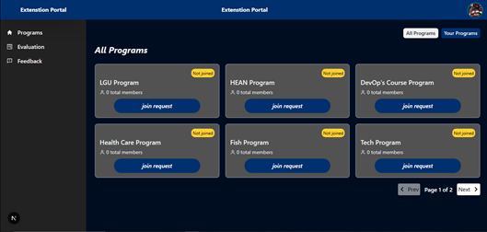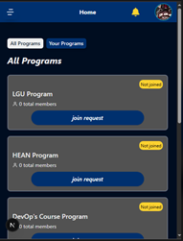
Figure 4. Landing Page of EduLink for Learner

Figure 5 shows the program page for learners, displaying all activities and resources within the selected program. It provides access to updates, assignments, meeting schedules, and member information.
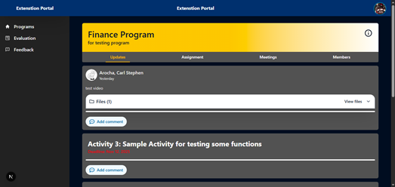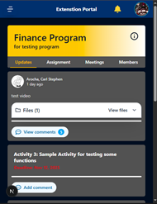
Figure 5. Program page for Learner

Figure 6 shows the landing page for the Instructor. On the program page the Instructor can see all their existing programs.
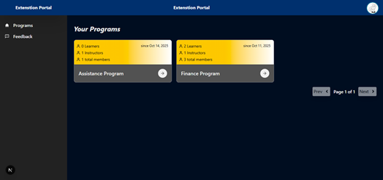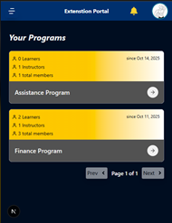
Figure 6. Landing Page of EduLink for Instructors

Figure 7 shows an enhanced program page for Instructors, allowing them to manage updates, meetings, and learning materials. Instructors can not only submit content but also conduct session evaluations within the system and utilize the built-in EDA to assess learners' performance and feedback.
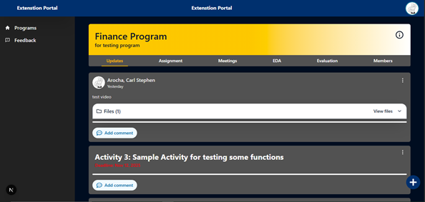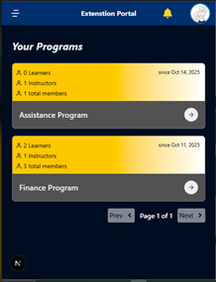
Figure 7. Program Page for Instructors

The Figure 8 shows the Administrator dashboard.This page provides the summary of the system status. It shows the information for the existing programs, user roles, files uploaded and active programs displaying their engagement and activity.
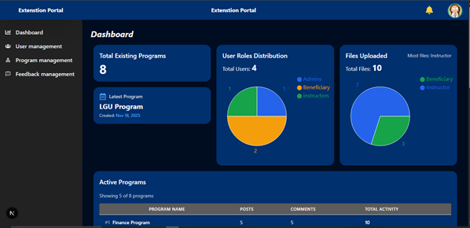
Figure 8. Administrator dashboard page

The Figure 9 displays the User management. The Administrator can view the list of all system users' information and their assigned roles. It is crucial for performing administrative duties like checking user information, assigning different roles to users, and carrying out actions such as editing or removing user accounts.
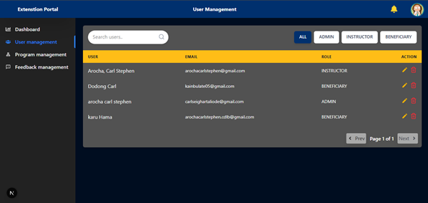
Figure 9. User management page

Figure 10 illustrates the program management section. On this page, the Administrator can view all existing programs. Each program displays the program title, creation date, and the total number of members in that program, along with their respective roles. The Administrator can use this page to search programs , add new programs, or manage existing programs by viewing members or editing/deleting the program.
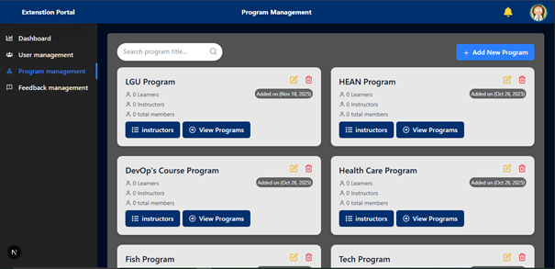
Figure 10. Program management page

Figure 11 shows the Feedback Management page. This page displays a list of submitted feedback entries, along with a summary of total feedback, differentiating between identified and anonymous submissions. Each entry details the program it concerns, the user's name if identified, and the submission date. This tool is essential for the Administrator to monitor user satisfaction, quickly identify areas for improvement, or determine if new features or fixes are needed for the Extension Portal.
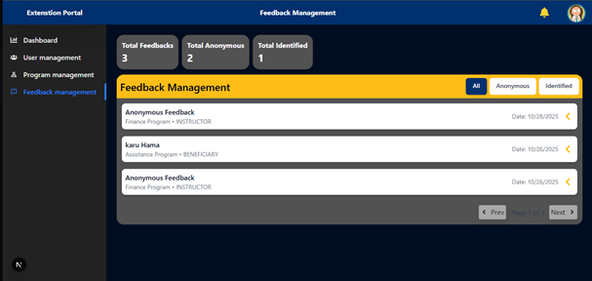
Figure 11. Feedback Management page

System Assessment using ISO 25010
Table 1 displays the product quality assessment of the system based on the ISO/IEC 25010 quality characteristics. Result shows that the most of the criteria such as Functional Suitability, Usability, Security, Compatibility, Performance, Maintainability, and Portability received excellent rating, Even though the Reliability rated good the overall composite mean of 4.56 demonstrate that the system meets the standards and delivers reliable, secure, and user-friendly functionality.
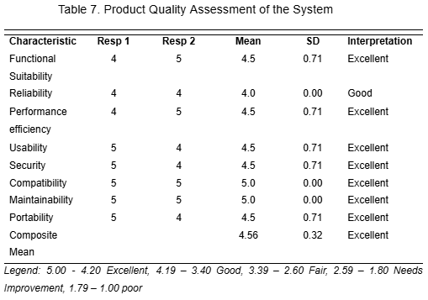
Table 1. Reliability test result for ISO 25010
Result of Technology Acceptance Model
Table 2 shows the overall evaluation results of the system based on the Technology Acceptance Model. Each section consists of 5 items rated using a four-point Likert scale. The result shows that all three categories achieve a mean score ranging from 3.56 to 3.59, which falls into the Highly Acceptable category. These findings indicate users find the system easy to navigate and operate.
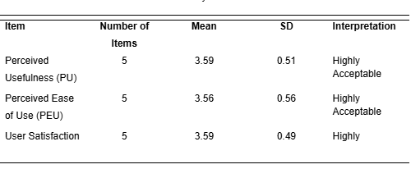
Table 2. Reliability test result for TAM

V. V. SUMMARY, CONCLUSION, AND
RECOMMENDATIONS
The Extension Program Assessment System successfully met its objectives and demonstrated significant potential to enhance the efficiency of extension program implementation by establishing a centralized LMS that consolidates learning materials, announcements, and program documentation into a single accessible platform, effectively addressing issues of scattered resources and inconsistent content distribution. Its responsive, user-friendly interface ensures seamless access across smartphones, tablets, and desktop devices, enabling participation regardless of technological limitations and accommodating users with varying levels of digital literacy. Additionally, the integration of a built-in evaluation and feedback module streamlines performance monitoring, allowing Instructors to administer assessments immediately after sessions and enabling Administrators to access automated analytics for tracking Beneficiary progress and overall program effectiveness, thereby eliminating delays associated with manual evaluations. The overall evaluation of the system further demonstrates strong user approval and reliable software quality performance; as shown in Table 1, the system achieved favorable results based on the ISO 25010 quality model, reflecting high ratings in functionality, usability, reliability, and performance efficiency, which validate its capability to deliver a stable and effective platform. Likewise, Table 2 presents the Technology Acceptance Model results, where all sections—each composed of five items rated using a four-point Likert scale—obtained mean scores ranging from 3.56 to 3.59, placing them within the Highly Acceptable category and indicating that users find the system intuitive, responsive, and practical for supporting extension activities. Collectively, these findings affirm that the Extension Program Assessment System not only meets its intended objectives but also delivers a positive and meaningful impact by enhancing operational efficiency, strengthening user experience, and improving the overall implementation and monitoring of extension programs.

REFERENCES
[1] Seki, K. (2015). Pantawid Pamilyang Pilipino Program and human development: An analysis of conditional cash transfer in the Philippines.
[2] Department of Social Welfare and Development. (2020). Pantawid Pamilyang Pilipino Program (4Ps) status report. DSWD.
[3]Howard, S. K., & Maton, K. (2011). Theorising knowledge practices: A missing piece of the educational technology puzzle. Research in Learning Technology, 19(3), 191–206.
[4]Li, K. C. (2018). The Evolution of Open Learning: A Review of the Transition from Pre-e-Learning to the Era of e-Learning. Retrieved from https://eric.ed.gov/?id=EJ1247658
[5]Gilbert, B. (n.d.). Online Learning: Revealing the benefits and challenges. Retrieved from https://fisherpub.sjf.edu/education_ETD_masters/303/
[6]Adjiovski, B., Bogatinoska, D. C., Ismajloska, M., & Malekian, R. (2024). Enhancing educational technology in lectures for school students with learning disabilities: A comprehensive analysis. SN Computer Science, 5, Article 716. https://doi.org/10.1007/s42979-024-03049-z
[7]Ellis, R. K. (2009). Field guide to learning management systems. ASTD Learning Circuits. Retrieved from https://assets.td.org/m/788c366c54cfed87/original/Microsoft-Word-LMS_fieldguide_2009.pdf
[8]Dai, B., He, Y., & Peng, M. (2025). Enhancing resilience in single-parent family adolescents in China: A randomized controlled trial based on home–school collaborative intervention. BMC Public Health, 25(1).
[9]Maro, C. E., Estaras, C. A. D., Ermino, A. K. G., Lelis, M. J., & Barola, R. C. (2024). Level of difficulties of working solo parents in balancing work and child’s education. Jurnal Pendidikan Progresif, 14(3), 402–415.
[10] Dote, B. B., & Garcia, N. P. (2025). Unveiling the experiences of learners with solo parents. European Journal of Education Studies, 12(8), 112–126.
[11] Ogunsaju, S. (1983). Educational supervision: Perspectives and practices in Nigeria. Ile-Ife, Nigeria: University of Ife Press.
[12] Peretomode, V. F. (1995). Principles and techniques of instructional supervision. In V. F. Peretomode (Ed.), Introduction to educational administration, planning and supervision (pp. 191–200). Lagos, Nigeria: Joja Educational Research & Publishers Ltd.
[13] Lumsden, B. D. (1985). The older adult as learners. Hemisphere Publishing.

APPENDIX F Curriculum Vitae

